Basic Function, Operation and Display
For Wireless Electricity Management System RCS-J24A
System Introduction
RCS-J24A is a bi-directional (2-way) electricity monitoring and control system with mobile phone remote monitoring and control feature. It can support up to 15pcs sensor terminals. Its No.1-14 can be paired with 2-way sensor plug sockets, 2-way RF switches and 1-way transmitters. Its HOUSE key can be paired with 1pc 1-way transmitter.
The 2-way sensor plug sockets and RF switches work as the sensor terminals and detect both the voltage and current consumed by the appliances (or lightings). The 1-way transmitter can be used to monitor the current from the live wire of the target.
The 2-way sensor plug sockets, RF switches and 1-way transmitter send the collected energy consumption information to the controller wirelessly so the data can be displayed on the LCD screen in real time, while the controller can send instruction to the sensor plug sockets and RF switches wirelessly to remotely switch them on/off. Furthermore, RCS-J24A allows the user to use mobile phone to check and control the household electricity consumption even he is in another city far away from his home.
The 2-way sensor plug sockets are used for appliances by simply working between the power supply socket and the appliances. The installation of the sensor plug sockets is very easy, just plug the sensor plug socket into the power supply socket near the appliance then use the sensor plug sockets to provide power for the appliances. While the 2-way RF switches need to be installed on the power supply line of the target lightings (or appliances if wanted), this will request an electrician to do the installation. For the 1-way transmitter, the user just needs to fix its sensor clamp around the live wire of the monitored object. The 1-way transmitter has only monitoring function, it can’t be remote controlled.
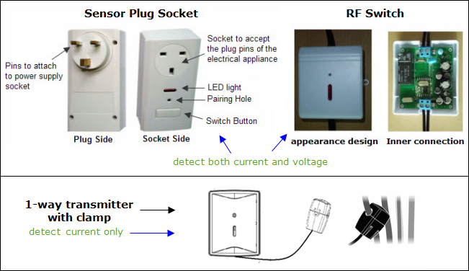
Full LCD Screen Characters
Means all characters that will be used on the display screen for the operation and function..
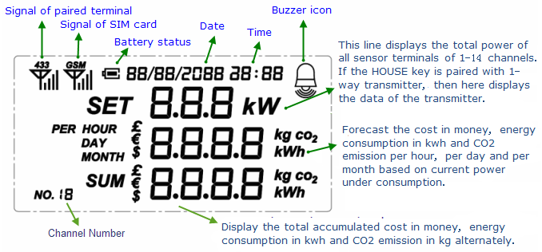
Remarks:
If no 1-way transmitter is paired with the Controller’s HOUSE key, the Default Display will display the total data of all sensor terminals from No.1-14 key. If the HOUSE key is paired with a 1-way transmitter, the Default Display will display the data of this 1-way transmitter as default information. The 1-way transmitter to be paired with the HOUSE key is usually used to monitor the whole household electricity consumption.
Installation
Step 1: Power on the Controller Unit
Install the battery inside the controller or use the power adapter to attach the Controller Unit to the power supply socket nearby. After the Controller is powered on, all its LED lights automatically turn on for a while and the LCD screen will enter into the Default Display with zero values as showed in below photo. At the same time, the LED lights of the Controller all go off.
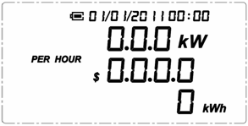
Now keep the Controller Unit powered on at all times.
Step 2: Pairing of the Sensor Plug Sockets with the Controller
The 2-way sensor plug sockets work as the sensor terminals and detect the power consumption data from the appliances. It also receives and implements the switching on/off instruction remotely from the Controller. To make the sensor plug socket communicate with the Controller, it need to be paired with the Controller first.
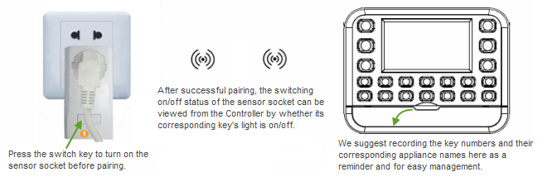
During pairing, it’s better to keep the sensor plug socket closest to the Controller. When pairing the sensor socket with the Controller, try to locate a power supply wall socket nearest to the Controller. Attach the sensor plug socket into the power supply socket and switch on the sensor socket by pressing its switch button. (Please refer to below photo for the location of the switch)
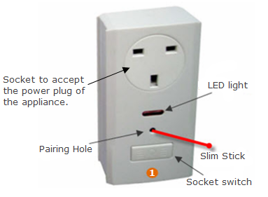
Upon the Default Display, press the "SETUP" key of the Controller and hold it for 3 seconds until all 1-14 numbered keys of the Controller are flashing. Then select one key from the 1-14 numbered keys, for example Key 1 (means channel 1 is to be used for the pairing), and press it shortly. Then only Key 1 will flash on the Controller and the LCD will display as below photo. The Controller is now waiting to be paired for Key 1 (channel 1).
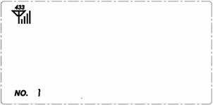
Now use a slim stick to push into the pairing hole of the sensor plug socket and hold there for about 6 seconds until the LED light on the sensor plug socket flashes quickly. The sensor socket is now starting to pair with the Controller. The pairing may take up to 60 seconds. When the pairing is successfully finished, the LED light on the sensor socket will stop flashing while the light of key 1 on the Controller will be on. And the LCD of the Controller will return to the Default Display. If the sensor socket is off, the light of its corresponding key on the Controller will also go off.

Now pull out the sensor socket from the power supply socket near the Controller and attach it again to the power supply socket near the actual electrical appliance to be monitored and controlled, then put the plug of the electrical appliance in the sensor plug socket. And the connected electrical appliance can now be monitored and controlled by the Controller remotely.

If the pairing can’t be finished within 60 seconds, the pairing will exit automatically, please try again.

Do the pairing in the same way for all other sensor sockets.
Step 3: Installation and pairing of the RF switches
If you’ve bought the RF switch, you need to read Step 3, otherwise please ignore it.

The RF switch is the 2-way sensor terminal mainly used for lightings. It detects the power consumption data from the lightings. It also receives and implements the switching on/off instruction remotely from the Controller. It can also be used for appliances, but its installation is not so easy as the sensor socket.
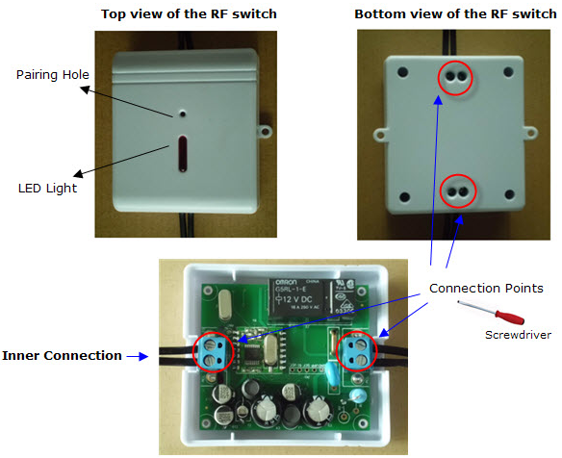
The RF switch may not be included in the standard package. If you’ve bought the RF switches, you need to ask for an electrician to install them. Please ask the electrician to refer to above-mentioned inner connection photo for the installation.

The RF switch can be paired with the Controller only after its installation. After installation, please switch on the power supply for the input line.

Upon the Default Display, press the "SETUP" key of the Controller and hold it for 3 seconds until all 1-14 numbered keys of the Controller are flashing. Then select one key from the 1-14 numbered keys, for example Key 2 (means channel 2 is to be used for the pairing), and press it shortly. Then only Key 2 will flash on the Controller. The Controller is now waiting to be paired for Key 2 (channel 2).

Now use a slim stick to push into the pairing hole of the RF switch and hold there for about 8 seconds until the LED light on the RF switch flashes quickly. The RF switch is now starting to pair with the Controller. The pairing may take up to 60 seconds. When the pairing is successfully finished, the LED light on the RF switch will stop flashing while the light of key 2 on the Controller will be on. And the LCD of the Controller will return to the Default Display. Now this line is monitored and controlled by the Controller via this RF switch.

If the pairing can’t be finished within 60 seconds, the pairing will exit automatically, please try again.

Do the installation and pairing in the same way for all other RF switches.
Step 4: Installation and pairing of the 1-way transmitter
If you’ve bought the 1-way transmitter, you need to read Step 4, otherwise please ignore it.

The transmitter with clamp is the 1-way sensor terminal mainly used for the main house electricity cable which stands for whole home electricity energy consumption. Its corresponding key on the Controller is the HOUSE key, which stands total house energy consumption.

But the 1-way transmitter can also be paired with No.1-14 key of the Controller. In that case, it can be regarded as a simple sensor terminal, just like the sensor socket. However, for the 1-way transmitter, the user can only use its key on the Controller to view its data, not able to remote control it.

Before pairing, please remove the clear plastic tab located on the back of the transmitter (marked: REMOVE BEFORE USING). The tab is an insulation sheet and once it is removed, the batteries inside will power on the transmitter and enable it to start sending signal to the Controller.
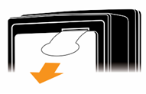
Upon the Default Display, press the "SETUP" key of the Controller and hold it for 3 seconds until all 1-14 numbered keys of the Controller are flashing. Press shortly the HOUSE key of the Controller and only the HOUSE key will flash on the Controller. The Controller is now waiting to be paired for HOUSE key.

Keep the transmitter close to the controller in the same room. Make sure that the plastic tab has been removed. Now use a slim stick to push into the pairing hole of the 1-way transmitter and hold there for about 3 seconds until the LED light on the transmitter flashes quickly. The transmitter is now starting to pair with the Controller. The pairing may take up to 60 seconds. When the pairing is successfully finished, the LED light on the transmitter will stop flashing while the light of HOUSE key on the Controller will be on. And the LCD of the Controller will return to the Default Display. The Default Display will begin to display the data of this transmitter.
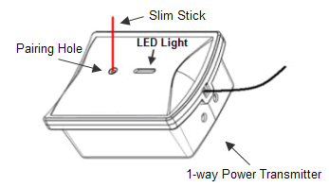
The user can choose to use No.1-14 key to pair with the 1-way transmitter, in this case, the key can’t remotely control the 1-way transmitter. And the light on the key only indicates whether the transmitter is online or offline.
How to install the transmitter and sensor clamp for the total home electricity energy consumption?
Place the transmitter near the input trunk cables for home (usually under the electricity meter). Fix the Sensor Clamp around the live wire or the null wire of the input trunk cables for the home. Make sure to let the wire pass through the clamp.
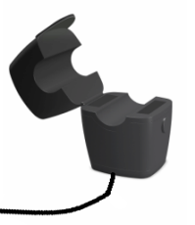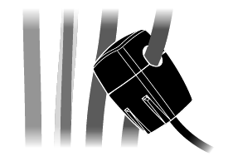
The Sensor Clamp immediately starts to detect the current and the transmitter sends the data to the controller. The monitoring system now starts to monitor the electricity energy consumption of home. And the user will begin to see the real data of home energy consumption on the LCD of the Controller.

The transmitter can be put flat in a dry place nearby or be stuck on the wall nearby.

Note: We have three kinds of optional sensor clamps for different diameters of cable: 10mm, 18mm and 25mm (as shown in below photo).
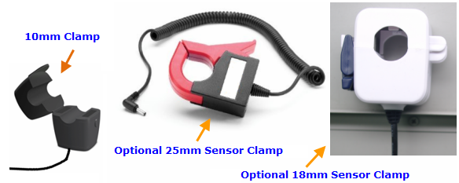

3-phase power supply
If the monitoring target is 3-phase, the user needs two more sensor clamps. Attach the DC plug of each extra sensor clamp into the DC sockets on the back of the Transmitter, as per below photo.
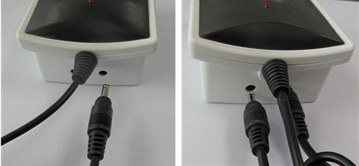
Fix the 3pcs of Sensor Clamps around the lines of Phase-A, Phase-B and Phase-C (Don’t fix the clamps around the ground wire and neutral wire).
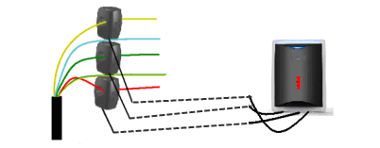
Note:
- If the HOUSE key of the Controller is paired with a 1-way transmitter, the Default Display of the LCD will display the data of the 1-way transmitter. If the HOUSE key of the Controller is not paired with a 1-way transmitter, the Default Display of the LCD will display the total data of No.1-14 key.
- The clamp can be used to detect the current in the live wire or null wire of the appliance. But usually the live wire or null wire of the appliance is not exposed and need to strip the skin of the power cable first to get the live wire or null wire. Please don’t do this if you are not an electrician.
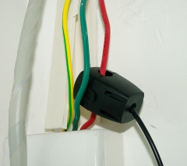
- Under single phase power supply, one 1-way transmitter can work on up to three objects by using 3pcs sensor clamps fixed around the null line or the live line of each object. In this case, the information displayed on the Controller for this transmitter is a total value of these three objects.
Settings and Functions of the Controller Unit
Settings of Date, Time, Currency, Tariff and Limited Power
The Date, Time, Currency, Tariff and Limited Power are to be set up continuously in the order as they show in this sentence.
Upon the Default Display of the Controller’s LCD, press the ON/OFF key and hold it for 3 seconds, the LCD display screen will first enter into the set up interface for Date (day/month/year), as below photo.
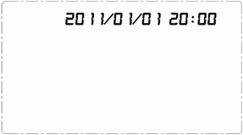
Now use the UP/DOWN key to get the correct value accordingly for each flashing value then shortly press the ON/OFF key to confirm until the complete data is set up and at the same time automatically enter into the set up interface for Time. Use the UP/DOWN key again to get the correctly value for each flashing value accordingly then shortly press the ON/OFF key to confirm and finish the setting for time and at the same time automatically enter into the set up interface for tariff Currency. Operate the same way to confirm the correct currency and the LCD display enters into the tariff setting interface, as below photo.
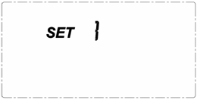
The tariff setting supports the setting for single tariff, two-tariff and three-tariff. First you see “1” flashing beside the word SET. It means single tariff. If there is only one tariff per day, please press the ON/OFF key upon the flashing “1” to confirm and enter into the setting interface for single tariff as below left photo, where 0.163 is the default value. If there are two different tariffs per day, please use the DOWN key to scroll from “1” to the flashing “2” and press the ON/OFF key to confirm. If there are three different tariffs per day, please use the DOWN key to scroll from “1” to the flashing “3” and press the ON/OFF key to confirm. The tariff setting interface for the 2 or 3-tariff is as below right photo, where the time is also available for setting.
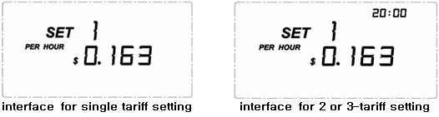
For single tariff setting: After pressing the ON/OFF key upon the flashing “1” beside the word SET, the LCD enters the interface for single tariff setting. Please use the DOWN/UP key to get the correct value for each flashing value accordingly then shortly press the ON/OFF key to confirm. The confirmation of the last flashing digit will lead the LCD to the setting interface for limited power.
For 2-tariff setting: After pressing the ON/OFF key upon the flashing “2” beside the word SET, the LCD enters the interface for 2 or 3-tariff setting. Please use the DOWN/UP key to get the correct flashing value and press ON/OFF key to confirm to finish the value of the first tariff, then the value of the Start Time for the first tariff will start to flash, use the DOWN/UP key to get each correct value and press ON/OFF key to confirm the Start Time. Then the LCD will enter the setting interface of the second tariff as below photo:
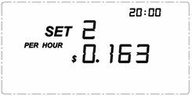
Operate the same way as you set the first tariff. The Start Time of the second tariff must be later than the first Start Time. The confirmation of the second Start Time will lead the LCD to the setting interface for limited power.
For 3-tariff setting: After pressing the ON/OFF key upon the flashing “3” beside the word SET, the LCD enters the interface for 2 or 3-tariff setting. Please use the DOWN/UP key to get the correct flashing value and press ON/OFF key to confirm to finish the value of the first tariff, then the value of the Start Time for the first tariff will start to flash, use the DOWN/UP key to get each correct value and press ON/OFF key to confirm the Start Time. Then the LCD will enter the setting interface of the second tariff as above photo. Do the same to set the tariff value and the Start Time for the second tariff, then the LCD will enter into the setting interface of the third tariff as below photo:
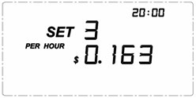
Operate the same way as you set the first and second tariff. The Start Time of the third tariff must be later than the second tariff and the Start Time of the second tariff must be later than the first Start Time. The confirmation of the third Start Time will lead the LDC to the setting interface for limited power.
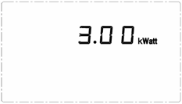
After the setting of the tariff, the LCD screen will automatically enter into the setting interface of Limited Power for all channels corresponding to No.1-14 keys, where you first see the number “3” flashing. The limited power for all channels is the same. Please use the DOWN/UP key to get the correct flashing value and press ON/OFF key to confirm. The range of the limited power can be set is 0.00kw to 3.00kw. The confirmation of the last digit will lead the LCD display to return to the Default Display.

Note:
  - The default Limited Power already set during the production is 3.00kWatt. That means if the power of any channel of No.1-14 key is over 3KW, the Controller will make an alarm.
  - The Limited Power alarm setting does not cover the 1-way transmitter for the HOUSE key.
  - During the setting, you can use the numbered key to input values directly instead of using the UP/DOWN key.
Default Display (what the user usually see from the display in normal working mode)
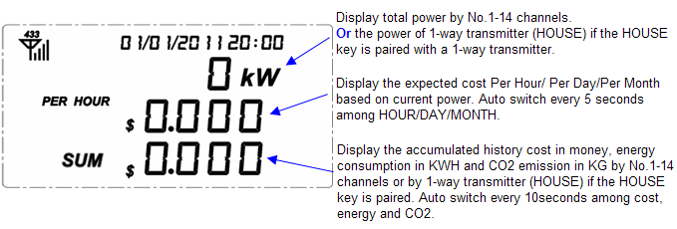
Switching on/off the electrical appliance (lightings) remotely from the Controller
To switch on/off one monitored electrical appliance (or lightings) remotely from the Controller, press the numbered key (1-14) of the targeted appliance on the Controller and hold it for 3 seconds. The numbered key will flash (other LED lights of the Controller will all turn off). While the numbered key is flashing, press the ON/OFF key shortly and the sensor plug socket (or RF switch) of the targeted appliance will be switched on/off, thus turning on/off the targeted appliance. Operate this way to switch between on and off status.
When the sensor socket (or RF switch) is switched on, its corresponding key on the Controller will light up. When the sensor socket (or RF switch) is switched off, its corresponding key on the Controller will light off. The user will know whether the connected appliances (lightings) are on or off by just checking whether their numbered key on the Controller are on or off.
If any key of No.1-14 keys is paired with 1-way transmitter, then this key can only be used to view the data of the 1-way transmitter. This key will not have the remote control function. And the light on the key only indicates whether the transmitter is online (paired) or offline (not paired).
Note:
- All sensor plug socket has one switch, the user may also use that switch to turn on/off the electrical appliance connected to the sensor plug socket.
Data Viewing
1) To view the power and the cost forecast based on current power of each channel, please just shortly press its corresponding numbered key (1-14) on the Controller upon the Default Display. The corresponding key number will be displayed at the left bottom. Please refer to below photo, it means channel 3 is consuming a power of 100w and such power consumption will cost 0.391$ for day.
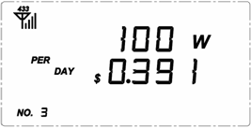
2) To view the total readings of all No.1-14 channels, simply press the TOTAL key. The LCD will display the power under consumption, the expected cost based on current power and the accumulated energy already consumed for current month starting from the 00:00 of 1st of current month. The number 15 will be displayed at the left bottom.
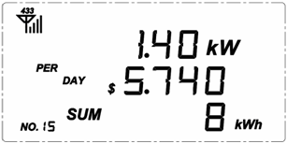
If there is no 1-way transmitter paired with the HOUSE key of the Controller, then above display is the Default Display.
3) To view the readings of HOUSE key, simply press the HOUSE key. The LCD will display its power under consumption and the cost forecast based on such power. The number 16 will be displayed at the left bottom.
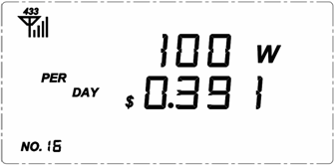
If there is a 1-way transmitter paired with the HOUSE key of the Controller, then above display is the Default Display.
During data viewing, 5 seconds idleness of key operation will return the LCD to the Default Display.
History Daily and Monthly Data Viewing
Upon the Default Display of the Controller, press the “DOWN” key and hold it for 3 seconds, the month value on the top of the LCD screen flashes. Use the UP/DOWN key to scroll to the past months and the KWHr value changes instantly to display the historical total KWHr consumed for that month. This historical data viewing can trace back to the past 12 months (including current month).
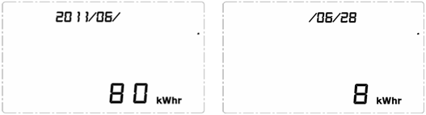
Upon the Default Display of the Controller, press the “UP” key and hold it for 3 seconds, the date value on the top of the LCD screen flashes. Use the UP/DOWN key to scroll to the past days and the KWHr value changes instantly to display the historical total KWHr consumed for that day. This historical data viewing can trace back to the past 30 days (including today).
Buzzer Setting
Upon the Default Display, Press the “HOUSE” key and hold it for 3 seconds to switch the Buzzer on or off. If the Buzzer is on, it will sound beeps in case there is an alarm in the system. The Buzzer was set as “off” during production.
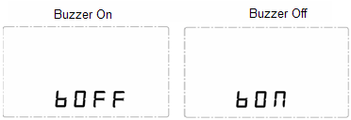
Limited Power Alarm
In case the power of any sensor plug socket (or RF switch) is higher than the set limited power, the LCD screen will display the alarm icon as below photo and the sensor socket (or RF switch) in alarm will have its corresponding number displayed at the bottom left corner. If the buzzer is set on during the alarming condition, the buzzer will make a sound every 5 minutes.
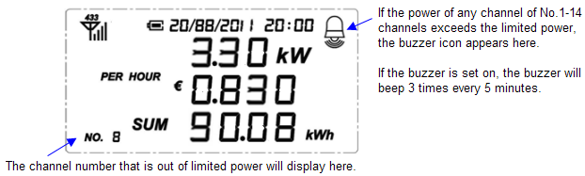
If several channels of No.1-14 keys are in limited power alarming condition at the same time, the channel with the largest power consumption will have its corresponding number displayed at the bottom left corner.\
Antenna Icon
If the Controller can receive signal from any channel of No.1-14 key or the 1-way transmitter paired with the HOUSE key, the 433MHz Antenna Icon should appear on the LCD as below photo.
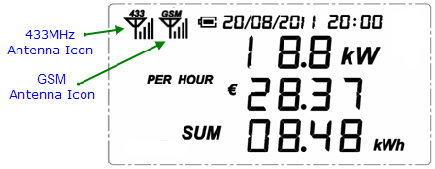
If a valid SIM card has been installed successfully on the Controller, the GSM Antenna Icon should appear on the LCD.
Warning: To un-install the SIM card from the Controller, make sure to power off the Controller first.
Meaning of the Remaining Battery Icons
Remaining Battery > 3.7v
3.5v < Remaining Battery <3.7v
Remaining Battery < 3.5v | + flash twice every second
Mobile Phone Remote Control
To realize the function of mobile phone remote control, please install a SIM card first into the controller. Please open the door of the battery box at the back of the controller and remove the battery then you’ll find the slot for the SIM card, please install the SIM card correctly into the slot. The SIM card should have a cell phone number, which should be used to receive command SMS from mobile phone and feedback to mobile phone.
Once the SIM card is installed successfully on the Controller, the GSM antenna icon should appear on the LCD, and the system is ready to be monitored and controlled via mobile phone. Please note that the Controller’s original functions and displays will not be affected by the mobile phone.
- To check the status of all No.1-14 channels, please send command SMS from the mobile phone to the SIM card inside the controller in the format as (SMS,QALL), including the brackets and comma. There is no blank between SMS and QALL.
  - “SMS” is the default password.
  - “QALL” is the command. “Q” stands for query command and “ALL” stands for the targets of the query, which means all available sensor terminals in the system, including the No.1-14 channel and the HOUSE channel.
The mobile phone will receive the feedback via a SMS from the SIM card inside the controller in format such as below:
(SMS,T1KW,1N10W,2F0W,3N1KW,4OL,5S100W)
“T” stands for the HOUSE channel, the “1KW” behind stands for that its power under consumption is 1KW. If HOUSE key is not paired with 1-way transmitter. “T” stands for the total data of No.1-14 channel.
The next character fields all start from a number, which is the channel number, or correspondingly No.1-14 key on the Controller. The letter behind it can be N, F, OL or S.
“N” stands for the status of “being switched on”, the number before it stands for the channel number, and the value after it stands for its power under consumption. “1N10W” means that the sensor socket or RF switch in channel 1 is being switched on and its power under consumption is 10 watts. “3N1KW” means that the sensor socket or RF switch in channel 3 is being switched on and its power under consumption is 1000 watts.
“F” stands for the status of “being switched off”, the number before it stands for the channel number, and the value after it is always 0w. “2F0W” means that the sensor socket or RF switch in channel 2 is being switched off and its power is 0 watt.
“OL” stands for this channel is paired but it has no signal. “4OL” means there is sensor socket, RF switch or 1-way transmitter paired in channel 4, but currently there is no signal received from this channel.
“S” stands for 1-way transmitter. “5S100W” means that channel 5 is a 1-way transmitter and its power under consumption is 100watts.
There is another symbol “NULL”, which stands for that nothing is paired in this channel.
- To check the status of one single channel, please send command SMS from the mobile phone to the SIM card inside the controller in format as (SMS,Q2), including the brackets and comma. There is no blank between SMS and Q2.
“Q” stands for query command and “2” stands for that the query target is channel 2.
The mobile phone will receive the feedback via a SMS from the SIM card inside the controller in format such as below:
(SMS, 2OL)
It means that the channel 2 is paired with controller but no signal is received from channel 2.
The user can check the status of several channels at the same time by sending command SMS in format as (SMS,Q1,Q2,Q10).
The mobile phone will receive the feedback via a SMS from the SIM card inside the controller in format such as below:
(SMS,1N10W,2OL,10NULL)
It means the sensor socket or RF switch in channel 1 is being switched on and its power is 10watts, channel 2 is paired but there is no signal and channel 10 is not paired with any sensor socket, RF switch or 1-way transmitter.
- To switch on all sensor sockets or RF switches in the system at one time from the mobile phone, please send command SMS from the mobile phone to the SIM card inside the controller in the format as (SMS,ALLON).
The mobile phone will receive the feedback via a SMS from the SIM card inside the controller in format such as below:
(SMS, T700W, 1N400W, 2N100W, 3S100W, 5S50W, 10S50W, 14OL)
The feedback SMS starts from T700W, providing the total power consumption first. Then it provides status and data for each channel. From above SMS, all available sensor socket or RF switches have been switched on. Actually it is channel 1 and 2 that have been switched on by the command. Channel 3, 5 and 10 are 1-way transmitters. Channel 14 has no signal for this moment.
If all channels are paired with 1-way transmitters only, the SMS feedback will be (SMS,NOT SUPPRT).
- To switch off all sensor sockets or RF switches in the system at one time from the mobile phone, please send command SMS from the mobile phone to the SIM card inside the controller in the format as (SMS,ALLOF).
The mobile phone will receive the feedback via a SMS from the SIM card inside the controller in format such as below:
(SMS, T107W, 1F0W, 2F0W, 3S10W, 5S10W, 10S87W, 14OL)
The feedback SMS starts from T700W, providing the total power consumption first. Then it provides status and data for each channel. From above SMS, all available sensor socket or RF switches have been switched off. Actually it is channel 1 and 2 that have been switched off by the command. Channel 3, 5 and 10 are 1-way transmitters. Channel 14 has no signal for this moment.
If all channels are paired with 1-way transmitters only, the SMS feedback will be (SMS,NOT SUPPRT).
- To switch on one single or several sensor plug sockets (or RF switches) from the mobile phone, please send command SMS from the mobile phone to the SIM card inside the controller in format as (SMS,S1N,S2F,S3N,S14N).
The “S” in S1N, S2F, S3N and S14N means single channel. The number behind the S stands for the channel number. The last letter N standing for switching on command and F standing fro switching off command.
This SMS commands to switch on channel 1, 3 and 14 and switch off channel 2.
The mobile phone will receive the feedback via a SMS from the SIM card inside the controller in format such as below:
(SMS,T700W,1N400W,2S300W,3NULL,14OL).
From above SMS, channel 1 has been switched on. Channel 2 is a 1-way transmitter, so it will not implement the instruction. Channel 3 is not paired with anything, so the command can’t be implemented. Regarding channel 14, it is paired but the Controller can’t get any signal from it. .
Resetting and Data Clearance
If the system needs to be reset and the data needs to be cleared from the control unit, please operate as below:
- Please pull out the power adapter and also pull out the battery first.
- Now Press the SETUP key and hold it there, then install the battery or attach the power adapter to the Controller. The LCD screen will display the full LCD screen characters as below and all LED lights on the Controller will flash once then keep on.
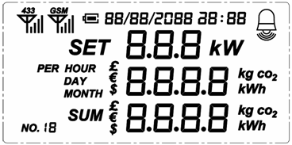
- When the programming version is displayed on the LCD, for example, 2.43 as displayed in below left photo, release the SET key. About 2 seconds later, the LCD will enter into the Default Display with zero values as below right photo. The data has now been cleared.
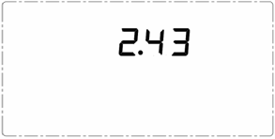
After resetting, the date returns to 01/01/2011 and the time returns to 00:00. The user need to do all the setting and pairing again.
In case the controller is powered off due to power cut or battery using up, the data will not be lost.
RJ45-USB Data Cable and SEMCS Software
The RJ45-USB Data Cable and the SEMCS software allow you to view your electricity consumption data and turn on/off the connected electrical appliances on your computer.


