User Manual

Wireless Home Energy Monitoring and Control System
RCS-J24B

Note to distributors: This user manual is our standard template. You may need to modify this manual according to your local market applications and the actual specification of your purchase order.

Thank you for purchasing this smart wireless electricity monitoring and control system. This guide will help you set up the wireless electricity management system quickly and easily.

What are included in the standard package?

Your package should contain:  1pc Controller Unit  1pc Power Adapter  3pc Sensor Plug Sockets  1pc RJ45-USB Data Cable (3m)  1pc Rechargeable Li-battery  and 1pc of the User Manual  Note:  The RCS-J24B system supports up to 14pcs of Sensor Plug Sockets (or RF switches) and 1pcs of 1-way Transmitters (each transmitter supporting up to 3pcs Sensor Clamps).  If you’ve bought extra Sensor Plug Sockets, RF switches or extra 1-way Transmitter with sensor clamps, please put them in appropriate place before installation. If not, please ignore related description. | 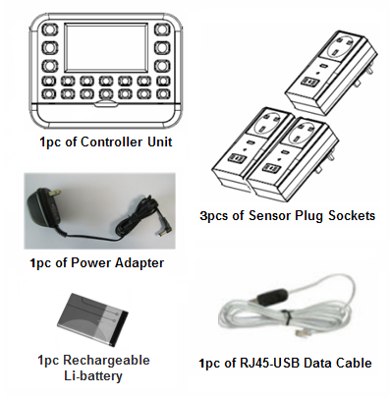

If any parts are missing, please contact your seller immediately.

The controller has 15 channels and can support to pair with three kinds of sensor terminals.
The 2-way sensor plug sockets (or RF switches) work as the sensor terminals and detects the power consumption data from the appliances (or lightings). The 1-way transmitter can be used to monitor the whole household electricity consumption. If no 1-way transmitter is paired with the Controller’s HOUSE key, the Default Display will display the total data of all 2-way sensor plug sockets (or RF switches) from No.1-14 key. If the HOUSE key is paired with a 1-way transmitter, the Default Display will display the data of this 1-way transmitter as default information.
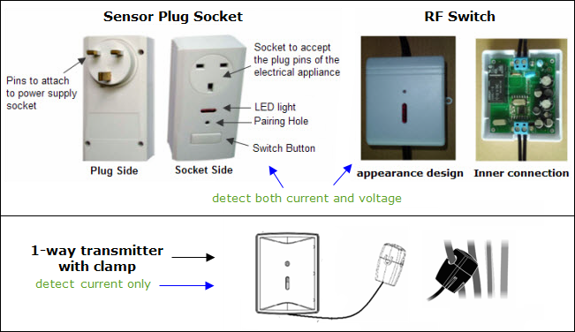
The 2-way sensor plug sockets (or RF switches) and 1-way transmitter send the collected energy consumption information to the controller wirelessly so the data can be displayed on the LCD screen in real time, while the controller can send instruction to the sensor plug sockets (or RF switches) wirelessly to remotely switch them on/off.
The 2-way sensor plug sockets are used for appliances by simply working between the power supply socket and the appliances. The installation of the sensor plug sockets is very easy, just plug the sensor plug socket into the power supply socket near the appliance then use the sensor plug sockets to provide power for the appliances. While the 2-way RF switches need to be installed on the power supply line of the target lightings (or appliances if wanted), this will request an electrician to do the installation. For the 1-way transmitter, the user just needs to fix its sensor clamp around the live wire of the monitored object.

Before installation, please pay attention to following information:

- Please read all instructions before you use the monitoring system
- Please shake the Controller, Sensor Plug Socket, RF switches or the 1-way Power Transmitter first before installation. In case you hear any sound from inside of the part, please don’t use it. Please replace it with your seller.
- Do not allow children or people unfamiliar with these instructions to use this electricity management system.
- Keep the Controller, Sensor Plug Socket, RF switch, 1-way Power Transmitter and Sensor Clamp away from sources of heat, water or any other liquid.
- Place the Controller, Sensor Plug Socket, RF switch, Power Transmitter and Sensor Clamp where children can not touch or pull.
- Don’t try to disassemble or modify any parts of this system. In case of problem, please consult your seller or contact.
- Don’t use the electricity management system for the appliance the electric wire of which is in abnormal conditions, such as loose wire, exposed copper wire, burnt mark on wire insulation layer, holes on wire layer or damage on electric meter. In case of such abnormalities, please consult a professional electrician immediately.
- Periodically check all wires and components to ensure there is no damage.
- Use a dry cloth to clean. Don’t use solvent, abrasive cleaners or water.
Technical Data
Model No. | RCS-J24B
System Type | Bi-directional (2-way)
LCD Screen Size (mm) | 79*42.5
Portability of the Controller Unit | Portable, can work with both power adapter and battery
With DC Power Adapter | Yes
Wireless Transmission | Yes
Indoor Minimum Covering Distance (over partitions) | 30m
Mounting Options | Desktop
PC Link | Yes, with RJ45 to USB data cable
PC Software | Yes
Compatibility with 3-phase | Yes for 1-way transmitter
Supported coding channels | 15 channels
Supported Sensor Plug Sockets (or RF switches) | 14pcs
Supported 1-way Power Transmitter | 1pc
Supported sensor clamps quantity per transmitter | 3pcs
Sensor Clamp Diameter | 10mm, 18mm and 25mm optional
1-way Transmitter Battery Life | 2 years
Signal Interval | Sensor Socket and RF Switch:  1 second per paired terminal in circle  Transmitter: 8 seconds
Data Accuracy | For Sensor Socket and RF Switch: ≤ 3%  For Transmitter:  1A—100A, 7% for 10mm and 18mm clamp
Displayed Cost Currencies | £, Euro, $
Customizable Voltage Range | 80-265V
Maximum Input Current | For sensor plug socket: 16A  For RF switch: 15A  For sensor clamp: 60A or 100A
Minimum Input Current | For sensor socket and RF switch: 0.01A  For sensor clamp: 0.2A
KW reading in real time | Yes
KWH reading in real time | Yes
Cost Forecast | Per Hour/Day/Month
Display of CO2 Emission | Yes
Memory function | Yes
KWH History Reading | Yes
Data Storage Capacity | 10 years
Date / Time Display | Date / Time
Indoor Temperature Display | No
Over-voltage Alarm Indicator | Yes
Low-voltage Alarm Indicator | Yes
Over-loading Alarm Indicator | Yes

First have a look of below photo to get a general idea of the meaning of each key, LCD symbols and value for the Main Display Interface and the Controller Unit.
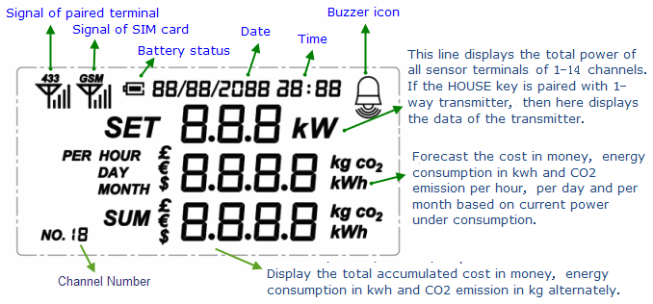
Note:
- This unit does not support GSM function. The signal of SIM card on the LCD does not meaning anything in this unit..
- If there is 1-way Power Transmitter paired in the system, the Default Display shows the data of the 1-way Power Transmitter. You need to short press the SUM key to switch to the interface that provides sum data for all monitored sensor sockets and RF switches.
- The 1-way transmitter is usually used to monitor the total house electricity consumption.

System Installation

Step 1: Attach the Controller Unit to a power supply socket.

Locate a place where has a power supply socket nearby and where is convenient for viewing and operating the Controller Unit.

Use the power adapter to attach the Controller Unit to the power supply socket nearby. After the Controller is connected to a power supply, all its LED lights automatically turn on for a while and the LCD screen will display with all available symbols on the LCD, as showed in below right photo.
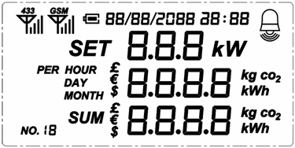
After that, the LCD screen remains a default display with zero value as below photo. At the same time, the LED lights all go off.
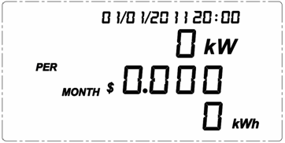
Now keep the Controller Unit powered on at all times.

Step 2: Pairing of the Controller with the Sensor Plug Sockets
The 2-way sensor plug sockets work as the sensor terminals and detect the power consumption data from the appliances. It also receives and implements the switching on/off instruction remotely from the Controller. To make the sensor plug socket communicate with the Controller, it need to be paired with the Controller first.

During pairing, it’s better to keep the sensor plug socket closest to the Controller. When pairing the sensor socket with the Controller, try to locate a power supply wall socket nearest to the Controller. Attach the sensor plug socket into the power supply socket and switch on the sensor socket by pressing its switch. (Please refer to below photo for the location of the switch)
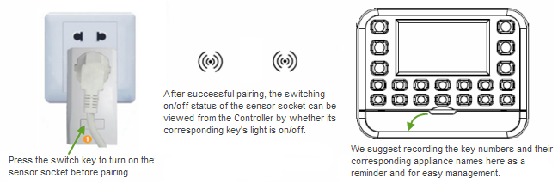
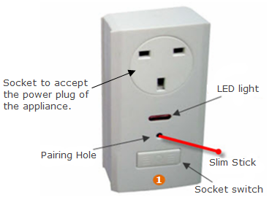
Upon the Default Display, press the "CODE" key of the Controller and hold it for 3 seconds until all 1-14 numbered keys, SUM key and key of the Controller are flashing quickly. Then select one key from the 1-14 numbered keys, for example Key 1 (means channel 1 is to be used for the pairing), and press it shortly. Then only Key 1 will flash on the Controller and the LCD will display as below photo. The Controller is now waiting to be paired for Key 1 (channel 1).
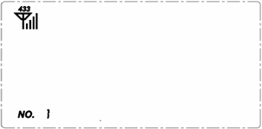
Now use a slim stick to push into the pairing hole of the sensor plug socket and hold there for about 6 seconds until the LED light on the sensor plug socket flashes quickly. The sensor socket is now starting to pair with the Controller and the LED light will flash one time every 6 seconds. The pairing may take up to 30 seconds. When the pairing is successfully finished, the LED light on the sensor socket will stop flashing while the light of key 1 on the Controller will be on. And the LCD of the Controller will return to the Default Display. If the sensor socket is off, the light of its corresponding key on the Controller will also go off.

Now pull out the sensor socket from the power supply socket near the Controller and attach it again to the power supply socket near the actual electrical appliance to be monitored and controlled, then put the plug of the electrical appliance in the sensor plug socket. And the connected electrical appliance can now be monitored and controlled by the Controller remotely.

If the pairing can’t be finished within 30 seconds, the pairing will exit automatically, please try again.

Do the pairing in the same way for all other sensor sockets. Thus establish communication between the Controller and all connected electrical appliances.

Note: We suggest you write down the button numbers and their corresponding appliance names for future reminder.

One Controller can support up to 14pcs of Sensor Plug Sockets (or RF switches) and 1pc of 1-way Power Transmitter.

Note: The Sensor Plug Socket can be used as a power supply socket for a multi-socket plug adapter. If so, all appliances attached to the multi-socket plug adapter will be monitored and controller as one unit through the Sensor Plug Socket.
Step 3: Installation and pairing of the RF switches
If you’ve bought the RF switch, you need to read Step 3, otherwise please ignore it.

The RF switch is the 2-way sensor terminal mainly used for lightings. It detects the power consumption data from the lightings. It also receives and implements the switching on/off instruction remotely from the Controller. It can also be used for appliances, but its installation is not so easy as the sensor socket.
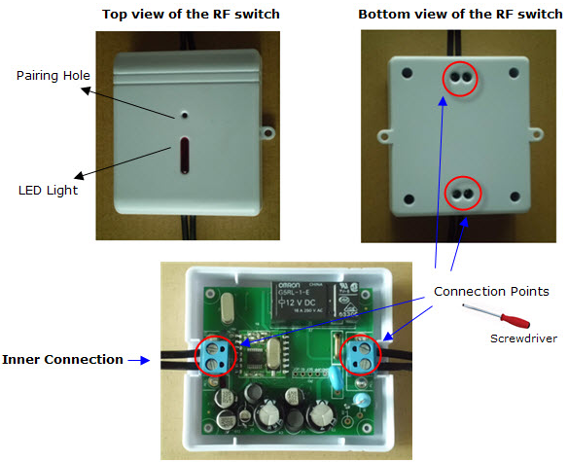
The RF switch may not be included in the standard package. If you’ve bought the RF switches, you need to ask for an electrician to install them. Please ask the electrician to refer to above-mentioned inner connection photo for the installation.

The RF switch can be paired with the Controller only after its installation. After installation, please switch on the power supply for the input line.

Upon the Default Display, press the "CODE" key of the Controller and hold it for 3 seconds until all 1-14 numbered keys, SUM key and key of the Controller are flashing. Then select one key from the 1-14 numbered keys, for example Key 2 (means channel 2 is to be used for the pairing), and press it shortly. Then only Key 2 will flash on the Controller. The Controller is now waiting to be paired for Key 2 (channel 2).

Now use a slim stick to push into the pairing hole of the RF switch and hold there for about 6 seconds until the LED light on the RF switch flashes quickly. The RF switch is now starting to pair with the Controller. The pairing may take up to 30 seconds. When the pairing is successfully finished, the LED light on the RF switch will stop flashing while the light of key 2 on the Controller will be on. And the LCD of the Controller will return to the Default Display. Now this line is monitored and controlled by the Controller via this RF switch.

If the pairing can’t be finished within 30 seconds, the pairing will exit automatically, please try again.

Do the installation and pairing in the same way for all other RF switches.
Step 4: Installation and pairing of the 1-way transmitter
If you’ve bought the 1-way transmitter, you need to read Step 4, otherwise please ignore it.

The transmitter with clamp is the 1-way sensor terminal mainly used for the main house electricity cable which stands for whole home electricity energy consumption. Its corresponding key on the Controller is the HOUSE key .

Before pairing, please remove the clear plastic tab located on the back of the transmitter (marked: REMOVE BEFORE USING). The tab is an insulation sheet and once it is removed, the batteries inside will power on the transmitter and enable it to start sending signal to the Controller.
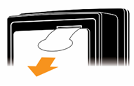
Upon the Default Display, press the "CODE" key of the Controller and hold it for 3 seconds until all 1-14 numbered keys, SUM key and key of the Controller are flashing.

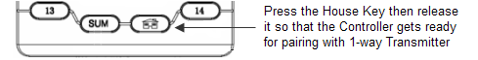

Press shortly the HOUSE key of the Controller then only the HOUSE key will flash on the Controller. The Controller is now waiting to be paired for HOUSE key.
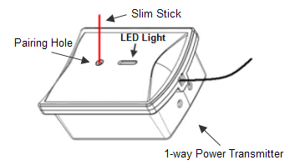
Keep the transmitter close to the controller in the same room. Make sure that the plastic tab has been removed. Now use a slim stick to push into the pairing hole of the 1-way transmitter and hold there for about 3 seconds until the LED light on the transmitter flashes quickly. The transmitter is now starting to pair with the Controller. The pairing may take up to 30 seconds. When the pairing is successfully finished, the LED light on the transmitter will stop flashing while the light of HOUSE key on the Controller will be on. And the LCD of the Controller will return to the Default Display. The Default Display will begin to display the data of this transmitter.

How to install the transmitter and sensor clamp for the total home electricity energy consumption?
Place the transmitter near the input trunk cables for home (usually under the electricity meter). Fix the Sensor Clamp around the live wire or the null wire of the input trunk cables for the home. Make sure to let the wire pass through the clamp.
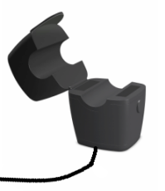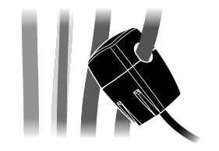
The Sensor Clamp immediately starts to detect the current and the transmitter sends the data to the controller. The monitoring system now starts to monitor the electricity energy consumption of home. And the user will begin to see the real data of home energy consumption on the LCD of the Controller.

The transmitter can be put flat in a dry place nearby or be stuck on the wall nearby.

Note: We have three kinds of optional sensor clamps for different diameters of cable: 10mm, 18mm and 25mm (as shown in below photo).
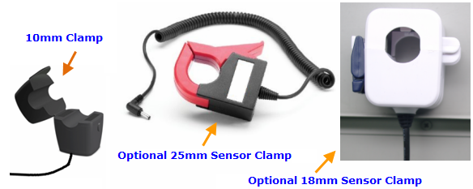

3-phase power supply
If the monitoring target is 3-phase, the user needs two more sensor clamps. Attach the DC plug of each extra sensor clamp into the DC sockets on the back of the Transmitter, as per below photo.
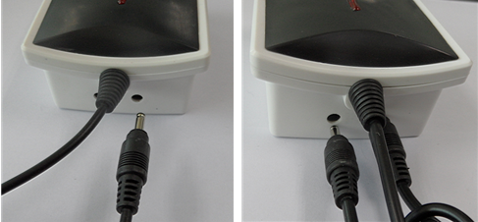
Fix the 3pcs of Sensor Clamps around the lines of Phase-A, Phase-B and Phase-C (Don’t fix the clamps around the ground wire and neutral wire).
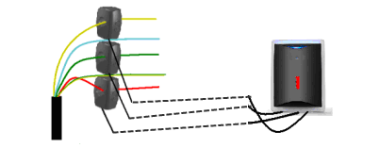
Note:
- If the HOUSE key of the Controller is paired with a 1-way transmitter, the Default Display of the LCD will display the data of the 1-way transmitter. If the HOUSE key of the Controller is not paired with a 1-way transmitter, the Default Display of the LCD will display the total data of No.1-14 key.
- The clamp can be used to detect the current in the live wire or null wire of the appliance. But usually the live wire or null wire of the appliance is not exposed and need to strip the skin of the power cable first to get the live wire or null wire. Please don’t do this if you are not an electrician.
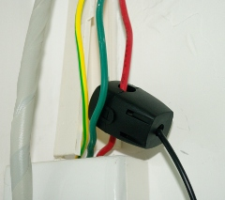
- Under single phase power supply, one 1-way transmitter can work on up to three objects by using 3pcs sensor clamps fixed around the null line or the live line of each object. In this case, the information displayed on the Controller for this transmitter is a total value of these three objects.
Up to now, the installation and pairing have been completed.
Settings and Functions of the Controller Unit

Settings of Date, Time, Currency, Tariff and Limited Power
The Date, Time, Currency, Tariff and Limited Power are to be set up continuously in the order as they show in this sentence.
After the Controller is powered on, press the ON/OFF key and hold it for 3 seconds, the LCD display screen will first enter into the set up interface for Date (day/month/year), as below photo.
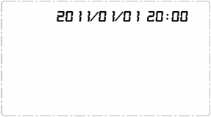
Now use the ON/OFF key to get the correct value accordingly for each flashing value then shortly press the ON/OFF key to confirm until the complete date is set up and at the same time the LCD will automatically enter into the set up interface for Time. Use the UP/DOWN key again to get the correct value for each flashing value accordingly then shortly press the ON/OFF key to confirm and finish the setting for time and at the same time the LCD will automatically enter into the set up interface for tariff Currency. Operate the same way to confirm the correct currency and then the LCD display enters into the tariff setting interface, as below photo.
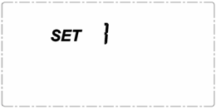
The tariff setting supports the setting for single tariff, two-tariff and three-tariff. First you see “1” flashing beside the word SET. It means single tariff. If there is only one tariff per day, please press the ON/OFF key upon the flashing “1” to confirm and enter into the setting interface for single tariff as below left photo, where 0.163 is the default value. If there are two different tariffs per day, please use the DOWN key to scroll from “1” to the flashing “2” and press the ON/OFF key to confirm. If there are three different tariffs per day, please use the DOWN key to scroll from “1” to the flashing “3” and press the ON/OFF key to confirm. The tariff setting interface for the 2 or 3-tariff is as below right photo, where the time is also available for setting.
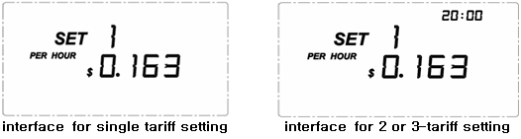

For single tariff setting: After pressing the ON/OFF key upon the flashing “1” beside the word SET, the LCD enters the interface for single tariff setting. Please use the DOWN/UP key to get the correct value for each flashing value accordingly then shortly press the ON/OFF key to confirm. The confirmation of the last flashing digit will lead the LCD to the setting interface for limited power.
For 2-tariff setting: After pressing the ON/OFF key upon the flashing “2” beside the word SET, the LCD enters the interface for 2 or 3-tariff setting. Please use the DOWN/UP key to get the correct flashing value and press ON/OFF key to confirm to finish the value of the first tariff, then the value of the Start Time for the first tariff will start to flash, use the DOWN/UP key to get each correct value and press ON/OFF key to confirm the Start Time. Then the LCD will enter the setting interface of the second tariff as below photo:
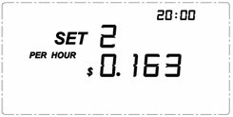
Operate the same way as you set the first tariff. The Start Time of the second tariff must be later than the first Start Time. The confirmation of the second Start Time will lead the LDC to the setting interface for limited power.
For 3-tariff setting: After pressing the ON/OFF key upon the flashing “3” beside the word SET, the LCD enters the interface for 2 or 3-tariff setting. Please use the DOWN/UP key to get the correct flashing value and press ON/OFF key to confirm to finish the value of the first tariff, then the value of the Start Time for the first tariff will start to flash, use the DOWN/UP key to get each correct value and press ON/OFF key to confirm the Start Time. Then the LCD will enter the setting interface of the second tariff as above photo. Do the same to set the tariff value and the Start Time for the second tariff, then the LCD will enter into the setting interface of the third tariff as below photo:
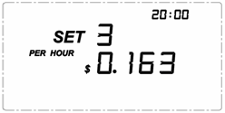
Operate the same way as you set the first and second tariff. The Start Time of the third tariff must be later than the second tariff and the Start Time of the second tariff must be later than the first Start Time. The confirmation of the third Start Time will lead the LCD to the setting interface for limited power.
After the setting of the tariff, the LCD screen will enter into the setting interface of Limited Power for all channels corresponding to No.1-14 keys, where you first see the number “3” flashing. Please use the DOWN/UP key to get the correct flashing value and press ON/OFF key to confirm. The range of the limited power can be set is 0.00kw to 3.00kw.
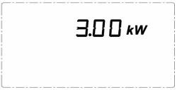
Note:
  - The default Limited Power already set during the production is 3000 Watt. That means if the power of any connected appliance is over 3KW, the Controller will make an alarm.
  - The Limited Power alarm setting does not cover the 1-way transmitter.
  - During the setting, you can use the numbered button to input values directly instead of using the UP/DOWN key.

You may also press the SUM key and hold it for 3 seconds to enter into the setting up interface for Currency, Tariff and Limited Power successively. The setting operation is the same.

Default Display
The default display is what the user usually sees from the LCD under normal working mode.
The first line is the power under consumption.
The second line is the cost forecast based on current power for one hour, one day and one month. The cost forecast switches once every 20seconds among PER HOUR, PER DAY and PER MONTH.
The third line is the accumulated total data of cost in money, energy in kWh and CO2 emission in kg since the Controller began working. They also switch once every 20 seconds.
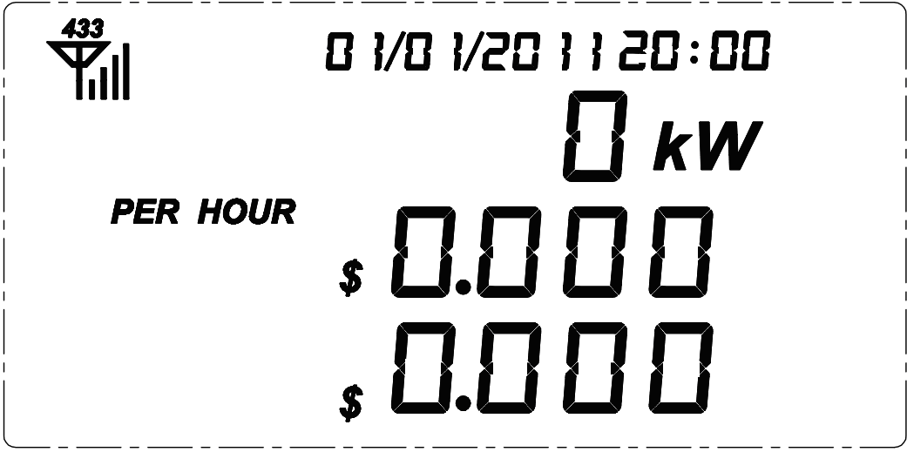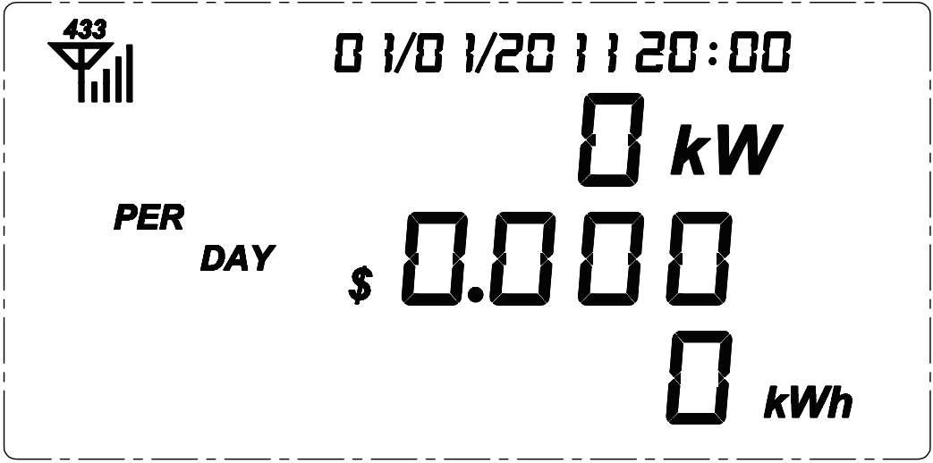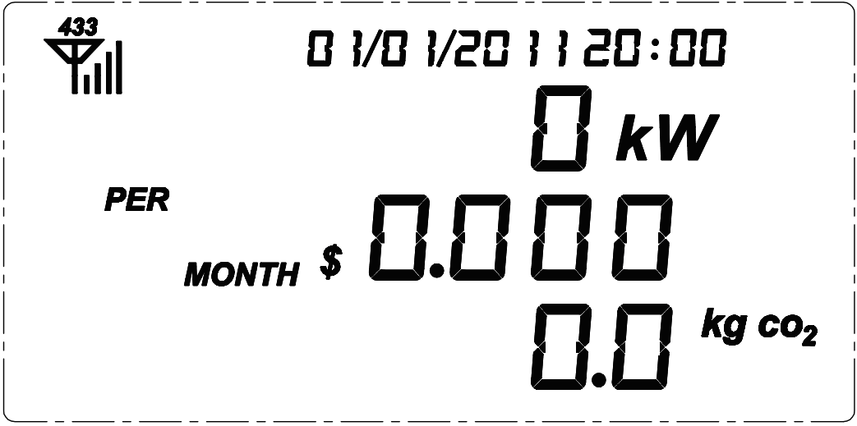
If no 1-way transmitter is paired with the HOUSE key, above data is the total data of all No.1-14 keys.
If there is 1-way transmitter paired with the HOUSE key, above data is the transmitter’s data. To view the total data of all No. 1-14 keys, please simply press the SUM key on the Controller.
Single Electrical Appliance Information Viewing
To view the readings of one single monitored electrical appliance on the LCD screen, simply press its corresponding numbered button on the Controller. Its information will instantly be displayed on the LCD screen. And its corresponding number will be displayed at the bottom right corner of the LCD screen. By press key 1 of the Controller will make the LCD display the data of No.1 socket (appliance).
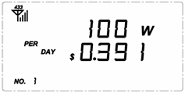

To view the sum data of all No.1-14 channels, simply press the SUM key of the Controller and the LCD will display the sum data of all connected appliances as below photo, where No.15 will be displayed at the left bottom corner as channel number.
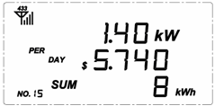

Note: If there is 1-way transmitter with clamp is paired with the HOME key, the default display will display the data of the transmitter. No.16 is the channel number for 1-way transmitter.

Switching on/off the monitored electrical appliance remotely from the Controller
To switch off one monitored electrical appliance remotely from the Controller, press the numbered key of the targeted appliance on the Controller and hold it for 3 seconds. The LED light of the numbered key will flash (other LED lights of the Controller will all turn off). While the numbered key is flashing, press the ON/OFF key shortly and the Sensor Plug Socket of the targeted appliance will be switched off, thus turning off the targeted appliance.

To switch on it again, press its numbered button on the Controller and hold it for 3 seconds, press the ON/OFF key shortly while the button is flashing and its Sensor Plug Socket will be switched on, thus turning on the targeted appliance.

If you’ve paired the RF switches in the system, please operate the same way for RF switch.

Note:
- All Sensor Plug Socket has one switch, you may also use that switch to turn on/off the electrical appliance connected to the Sensor Plug Socket.
- The user is able to tell whether the connected appliance is on or off by just viewing whether the LED light of its corresponding key on the Controller is on or off.
- You are not able to switch on/off remotely from the Controller 1-way power transmitter which is paired in the system.

Buzzer Setting
Press the “HOUSE” key and hold it for 3 seconds to switch the Buzzer on or off. If the Buzzer is on, it will sound beeps in case there is an alarm in the system. The Buzzer was set as default “off” during production.
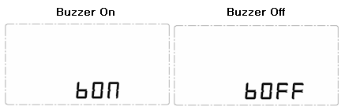

Historical Data Viewing
Upon normal working mode, press the “UP” key and hold it for 3 seconds, the date value on the top of the LCD screen flashes. Use the UP/DOWN key to scroll to the past days and the KWHr value changes instantly to display the historical total KWHr consumed for that day. This historical data viewing can trace back to the past 30 days.
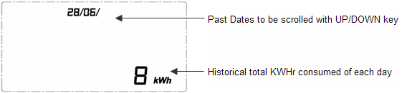

Press the “DOWN” key and hold it for 3 seconds, the month value on the top of the LCD screen flashes. Use the UP/DOWN key to scroll to the past months and the KWHr value changes instantly to display the historical total KWHr consumed for that month. This historical data viewing can trace back to the past 12 months.
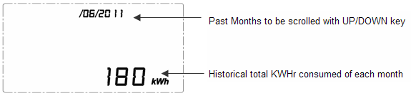
Resetting and Data Clearance
If the unit needs to be reset and the data needs to be cleared from the unit, please operate as below:
1) Please pull out the power adapter first.
2) Now Press the ON/OFF key and hold it there, then attach the power adapter. The LCD will display all available symbols and all LED lights on the Controller will be on. Then release the ON/OFF key, all LED lights of the Controller will go off. Then the LCD will display the programming version number as below photo. Three seconds later, the LCD will return to default display with zero value. Now the data has been cleared.
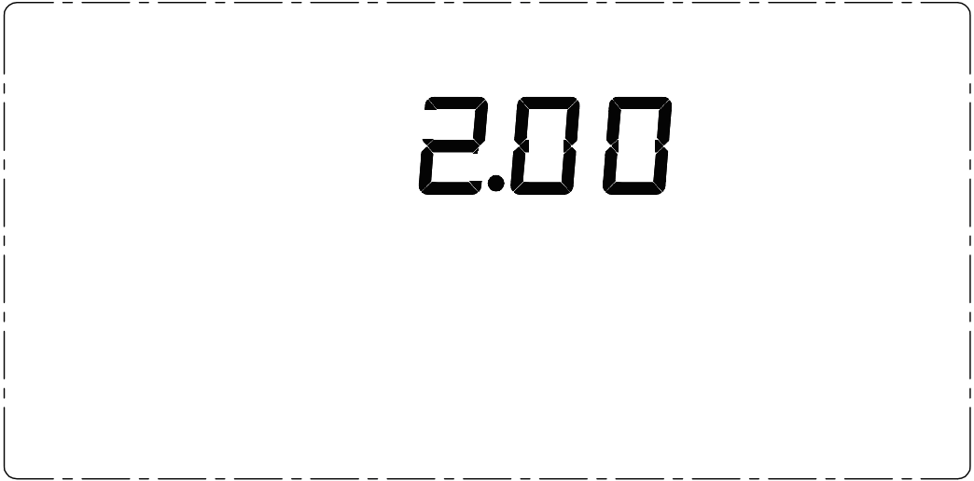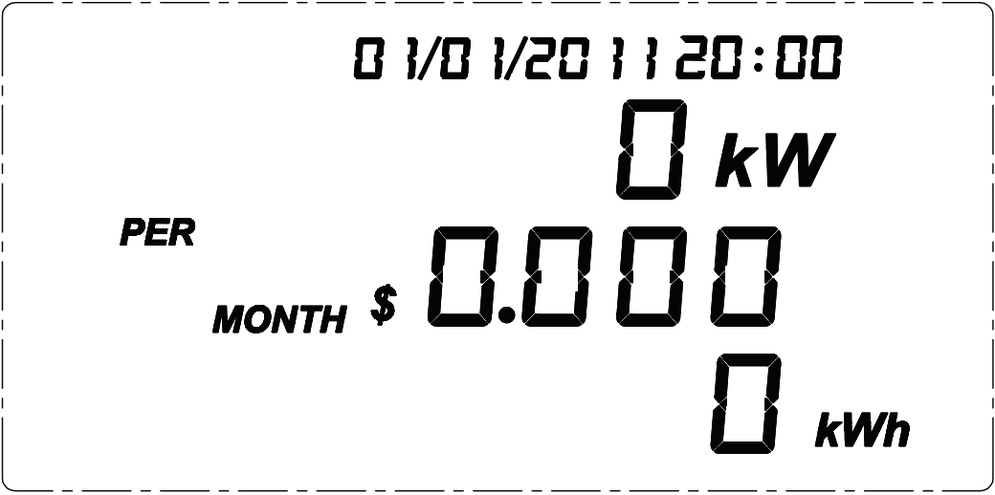

RJ45-USB Data Cable and SEMCS Software
The RJ45-USB Data Cable and the SEMCS software allow you to view your electricity consumption data and turn on/off the connected electrical appliances on your computer. Please download the software on the webpage http://www.sailwider-smartpower.com/document/download.htm. Before installation of the software, please read carefully the help file.
