User Manual
For Wireless Energy Monitor RCS-S12A

Note to distributors: This user manual is our standard template. You may need to modify this manual according to your local market applications and the actual specification of your purchase order.

Thank you for purchasing this smart wireless electricity monitor. This guide will help you set up the wireless monitoring system quickly and easily.

What are included in the standard package?

Your package should contain:  1pc of Display Unit  1pc of Power Adapter for the Display Unit  1pc of 1-way Power Transmitter  1pc of Sensor Clamp fixed on the transmitter  1pc of RJ45-USB Data Cable (3m)  as displayed in the right photo  and 1pc of the User Manual  The monitor can support up to 15pcs of 1-way power transmitters and each transmitter can support up to 3pcs of sensor clamps. | 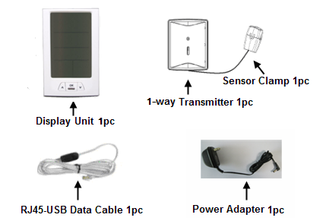
If you’ve bought extra transmitters and sensor clamps, please put them in appropriate place before installation.

If any parts are missing, please contact your seller immediately.

Before installation, please pay attention to following information:
- Please read all instructions before you install and use the monitoring system
- Please shake the Display Unit and the Power Transmitter first before installation. In case you hear any sound from inside of the part, please don’t use it. Please replace it with your seller.
- Do not allow children or people unfamiliar with these instructions to use your monitoring system.
- Keep the monitor, transmitter and sensor clamp away from sources of heat, water or any other liquid.
- Place the monitor, transmitter and sensor clamp where children can not touch or pull.
- Don’t try to disassemble or modify any parts of the monitoring system. In case of problem, please consult your seller or contact…..
- Don’t use the monitoring system if you find your electric wire in abnormal conditions, such as loose wire, exposed copper wire, burnt mark on wire insulation layer, holes on wire layer or damage on electric meter. In case of such abnormalities, please consult a professional electrician immediately.
- Periodically check all wires and components to ensure there is no damage.
- Use a dry cloth to clean. Don’t use solvent, abrasive cleaners or water.

Technical Data

Model No. | RCS-S12A
System Type | Uni-directional (1-way)
LCD Screen Size (mm) | 58*93
Portability of the Display Unit | Portable, can work on batteries
With DC Power Adapter | Yes
Wireless Transmission | Yes
Indoor Minimum Covering Distance (over partitions) | 30m
Mounting Options | Desktop
PC Link | Yes, with RJ45 to USB data cable
PC Software | Yes, downloadable free
Compatibility with 3-phase | Yes
Supported coding channels | 15 channels
Supported transmitter quantity | 15pcs
Supported sensor clamps quantity | 3pcs per transmitter
Sensor Clamp Diameter | 10mm, 18mm and 25mm optional
Transmitter Battery Life | 2 years
Signal Interval | 8 seconds
Data Accuracy | 1A—100A, 7% for 10mm and 18mm clamp
Displayed Cost Currencies | £, €, $
Customizable Voltage Range | 80-265V
Maximum Input Current (under 220V) | 60A or 100A
Minimum Input Current (under 220V) | 0.2A
KW reading in real time | Yes
Cost Forecast | Per Hour/Day/Month
Display of CO2 Emission | Yes
Memory function | Yes
Automatic Switching of Display Modes | Yes
Data Storage Capacity | 2 years
Date / Time Display | Yes
Indoor Temperature Display | Yes
Compatible with Economy 7 | Yes
Over-voltage Alarm Indicator | No
Low-voltage Alarm Indicator | No
Over-loading Alarm Indicator | No

System Installation
Step 1: Attach the Display Unit to a power supply socket.
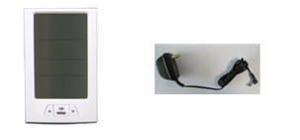
Use the power adapter to attach the Display Unit to a power supply socket nearby. After being connected to power supply, the LCD screen of the Display Unit will show as below photo with dashes and zero value.
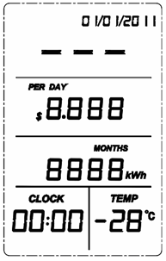
Before pairing with transmitter and setting, the Display Unit is with dash or “8” data value on the LCD. Now keep the Display Unit powered on at all times.
Step 2: Make the 1-way Power Transmitter start to work
Keep the Transmitter as close to the Display Unit as possible. Pull out the clear plastic tab (marked with “REMOVE BEFORE USING”) from the back of the transmitter. The tab is an insulation sheet, once it is pulled out, the built-in batteries inside will make the transmitter start to work immediately.
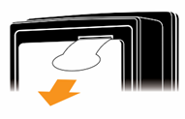
Step 3: Pairing of the Display Unit with the Transmitter
Now press the UP/DOWN key of the Display Unit to choose the channel number. The Display Unit has 15 channels. Upon pressing the UP/DOWN key, the channel numbers will appear under CLOCK symbol, as below photo.
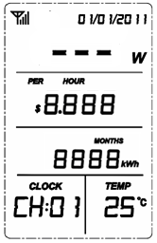
CH:01 stands for channel No.1. Let’s start from CH01. Press the UP/DOWN key to choose CH01, then press the “DOWN” key and hold it for 3 seconds. Release the “DOWN” key when the antenna icon is flashing at the top left corner of the LCD screen, as below photo. The Display Unit is now ready for pairing.
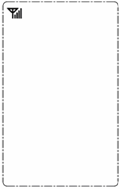
Keep the transmitter close to the Display Unit in the same room. Make sure that the plastic tab has been removed. Now use a slim stick to push into the pairing hole of the transmitter (as shown in below photo) and hold it there until the LED light of the transmitter flashes quickly. The transmitter is now starting to pair with the Display Unit.
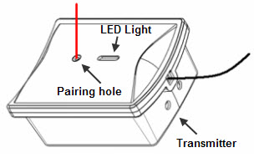
The pairing may take up to 60 seconds. When the pairing is successfully finished, the antenna icon stops flashing and stays on the top right corner of the LCD screen. The first line value on the LCD screen will change from dashes to 0 Watt.
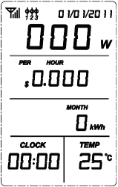
If the Display Unit and the Transmitter failed to get paired within 60 seconds, they will exit the pairing automatically. Please try pairing again.

If more 1-way Power Transmitters need to be paired, just choose different channel number and repeat in the same way. Up to 15pcs of Transmitter can be paired with one RCS-S12A Display Unit. The transmitter sends pairing signal for 60 seconds once it is in pairing mode, so please wait for 60 seconds before you pair the next transmitter.

Note: If more than one transmitter is to be paired, prepare a note and write down the channel numbers and their corresponding transmitters for future reminder.

Step 4: Installation of the 1-way Transmitter and the Sensor Clamp

The transmitter already has a sensor clamp fixed together with it. You may choose to put the Transmitter in a dry place near the monitored object or stick the Transmitter on the wall near the monitored object.

Fix the Sensor Clamp around the live wire or the null line (also called zero line) of the monitored object, just as below photo is showing (Don’t fix the clamp around the ground wire). Make sure to let the line pass through the clamp.
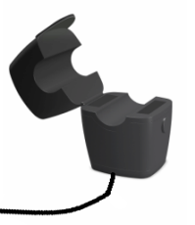
Note: There are three kinds of optional sensor clamp, one with the diameter of 10mm (as shown in above photo); the others are 18mm and 25mm (as shown in below photo).
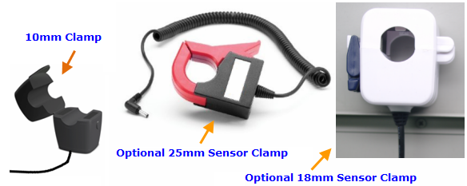
The Sensor Clamp immediately starts to sensor the current and the energy monitoring system starts to work. The LCD screen of the Display Unit should now display the electricity information of the monitored object in real time.
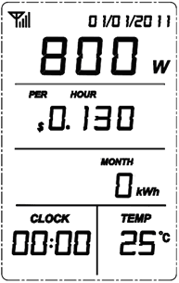
One power transmitter can support up to 3 sensor clamps which can be used for up to 3 different single-phase power supply or be used for 3-phase power supply.

3-phase power supply

If the monitored object use a 3-phase power supply. You need two more sensor clamps. Attach the DC plug of each sensor clamp into the DC sockets on the back of the Transmitter.

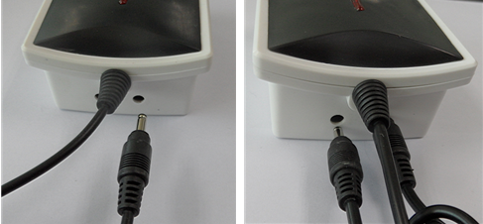

Fix the 3pcs of Sensor Clamps around the lines of Phase-A, B and C (Don’t fix the clamps around the ground wire and neutral wire).
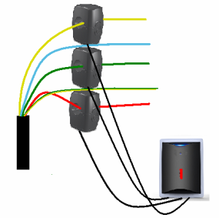
Note: Under single phase power supply, one transmitter can work on up to three objects by using 3pcs sensor clamps fixed around the live wire or the null line of each object (if they are close enough to the transmitter). In this case, the information displayed on the screen of the Display Unit for this transmitter is a total value of these three objects.

Settings and Functions of the Display Unit
After the Display Unit and the Transmitter have been successfully paired, we need to make some settings of the LCD screen so that we can get desired correct information from the Display Unit.

Full LCD Symbols
First have a look at the full LCD symbols to get an idea of the meaning of each word and value for the Main Display Interface and how the monitor works.

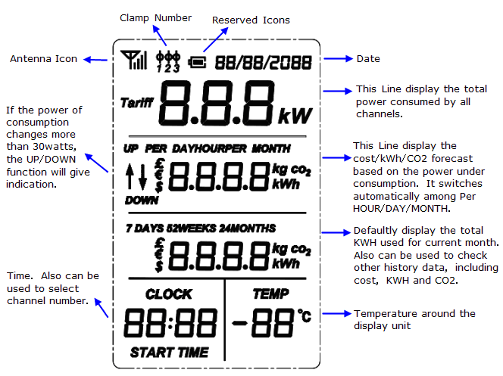
Default Display
Also have a look at an example of the Default Display as below photo. The Default Display is what the user usually sees from the LCD in normal working mode.
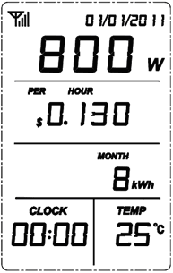
Resetting and Data Clearance
If the unit needs to be reset and the data needs to be cleared from the display unit, please operate as below:
- Cut off the power (Pull the power adapter plug out of the display unit. If there are batteries inside, remove them first). Then press the UP key and DOWN key simultaneously and hold it there. Now attach the power adapter again to the display unit. The LCD screen will display the full LCD symbols for 3 seconds:
- After the LED light flashes twice, release the UP key and DOWN key. The LED light will stop flashing and keep on. The LCD screen will display the programming version number.
- After another 3 seconds, the LED light goes off and the display returns to the Default Display with dashes and zero value. Up to now the data clearance is finished. The transmitters need to be paired again with the Display Unit and all settings need to re-done.
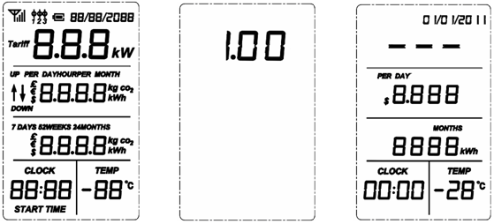

Coding Channels View
If more than one Transmitter is paired with the energy Display Unit, the Main Display Interface gives the total information of all paired transmitters. To view the information of a single transmitter, press the UP/DOWN key to tune into different coding channels for different Transmitters. The CLOCK value will accordingly change to display the channel numbers for all paired transmitters (from CH01-CH15). And the values on the LCD screen will immediately change accordingly to provide real time information for the tuned channels. Below photo is what the user sees from the LCD when he scrolls the UP/DOWN key to channel No.1.
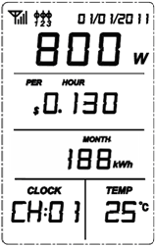
Settings of Date, Time, Currency, Tariff, CO2 Factor, and Buzzer:
Upon Default Display, press the OK key and hold it there for 3 seconds, after the LED light flashes twice release the OK key. The LCD will enter into the Main Setting Interface, where the date 01/01/2011 is flashing. If the user does not want to set the date, please use the DOWN key to scroll to other items to be set, then press OK key to do the setting for the selected item. The scrolling order is date, time, currency, tariff and CO2 factor and buzzer. When the item is selected it will flash. Press the UP key upon the flashing 01/01/2011 or press the DOWN key upon flashing bOFF will exit the setting.
Main Setting Interface
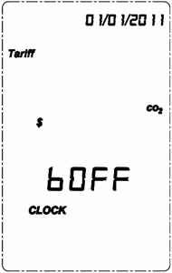
When 01/01/2011 (day/month/year) is flashing, press OK key shortly and enter into the setting interface for date. Use the UP key or the DOWN key to scroll to the correct value for each flashing number and press OK key to confirm the value.
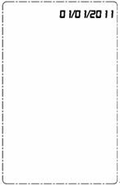
The confirmation of the last value of the date will return the LCD automatically to the Main Setting Interface, where the data is flashing. Now use the DOWN key to scroll to the flashing CLOCK. Press OK key to enter into the setting interface for time. Use the UP key or the DOWN key again to scroll to the correct value for each flashing number and press OK key to confirm the value.
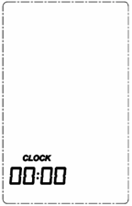
Set the same way for currency, where $, € and ₤ are available for setting.

The confirmation of the currency by pressing the OK key will return the LCD automatically to the Main Setting Interface. Now use the DOWN key to scroll to the flashing Tariff symbol and press the OK key to enter into the setting interface of Tariff.

The tariff setting supports the setting for single tariff, two-tariff and three-tariff. First you see “1” flashing beside the word Tariff. The flashing “1” means single tariff. If there is only one tariff per day, please press the OK key directly upon the flashing “1” to enter into the setting interface If it is two-tariff applicable, then scroll the flashing “1” to flashing “2” and press OK key to enter into the setting interface. If it is three-tariff applicable, please scroll to flashing “3” and press OK key.
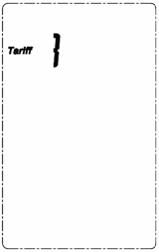
If single tariff setting: The setting interface for single tariff as below photo, where 0.163 is the default value. Use the UP key or the DOWN key again to scroll to the correct value for each flashing number and press OK key to confirm the value. The confirmation of the last value of the date will return the LCD automatically to the Main Setting Interface.
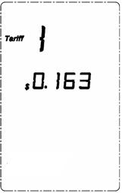
For two-tariff setting interface: The first setting interface is as below left photo, where shows tariff 1 and the time is also available for setting. Please use the DOWN/UP key to get the correct flashing value and press OK key to confirm to finish the value of the first tariff, then the value of the Start Time for the first tariff will start to flash, use the DOWN/UP key to get each correct value and press OK key to confirm the Start Time. Then the LCD will enter the setting interface of the second tariff as below right photo.
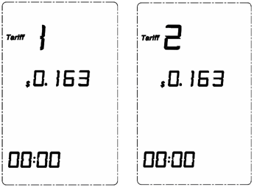
Operate the same way as you set the first tariff. The Start Time of the second tariff must be later than the first Start Time. The confirmation of the second Start Time will lead the LCD back to the Main Setting Interface.
For 3-tariff setting: The first setting interface is as below left photo, where shows tariff 1 and the time is also available for setting. Please use the DOWN/UP key to get the correct flashing value and press OK key to confirm to finish the value of the first tariff, then the value of the Start Time for the first tariff will start to flash, use the DOWN/UP key to get each correct value and press OK key to confirm the Start Time. Then the LCD will enter the setting interface of the second tariff as below middle photo. Do the same to set the tariff value and the Start Time for the second tariff, then the LCD will enter into the setting interface of the third tariff as below right photo:
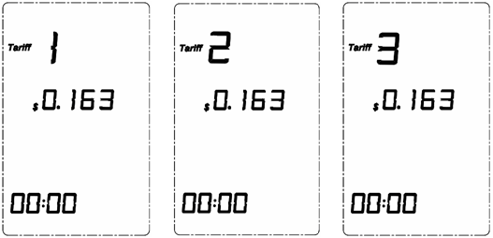
Operate the same way as you set the first and second tariff. The Start Time of the third tariff must be later than the second tariff and the Start Time of the second tariff must be later than the first Start Time. The confirmation of the third Start Time will lead the LCD back to the Main Setting Interface. Now use the DOWN key to scroll to the flashing CO2 symbol and press OK key to enter into the setting interface for CO2 factor as below photo.
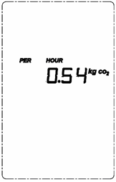
The CO2 factor is to be used to calculate how much CO2 is produced by the consumption of 1kwh. The default factory is 0.54. If you don’t know much of this, you can use this factor for your reference. Use the UP key or the DOWN key to scroll to the correct value for each flashing number and press OK key to confirm the value.

The confirmation of the last value of the CO2 factor will return the LCD automatically to the Main Setting Interface, where BEEP is flashing. Press OK key to enter into the setting interface for buzzer.
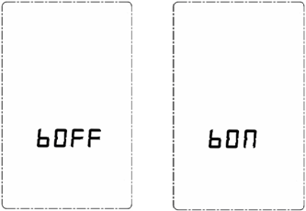
Use the DOWN/UP key to switch between bOFF and bON and press OK key to confirm. When the buzzer is set bON, the key clicking on the Display Unit will make sound. The default setting in the factory production is bOFF. The confirmation of the buzzer setting will return to the Main Setting Interface.

Pressing the UP key upon the flashing DATE or pressing the DOWN key upon the flashing BEEP will return the LCD to the Default Display.
History Data Viewing
Upon Default Display, Press the UP key and hold it there for about 3 seconds until the LCD enter into the history data view display as below photo, where is displaying the accumulated energy consumption for current day:
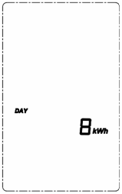
Now press shortly the DOWN key will switch the data of energy consumption, money spent and CO2 emission for current day.
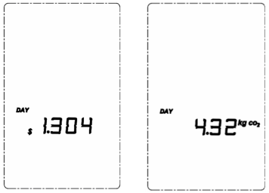
Upon history data viewing, press shortly the UP key will switch the history data among different history periods from current day to last 7 days, current week, last 52 weeks, current month and last 24 months.
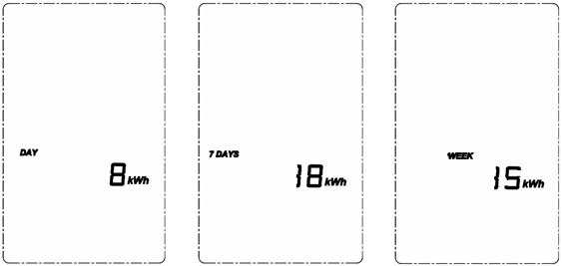
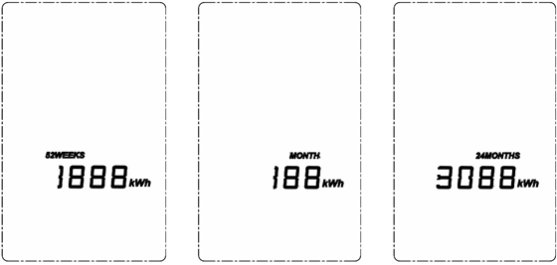
Idleness of key operation for 20 seconds will exit the history data view and the LCD will return automatically to Default Display.Upon history data viewing, press shortly the UP key will switch the history data among different history periods
RJ45-USB Data Cable and SEMS Software
The RJ45-USB Data Cable and the SEMS software allow you to view your electricity consumption data on your computer. Please download the software here http://www.sailwider-smartpower.com/document/download.htm. Before installation of the software, please read carefully the file help file.


