User Manual
Wireless Home Solar Energy Monitor RCS-S22F

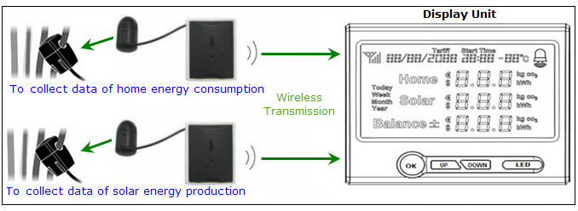
We strongly suggest you to read over this user manual before you start the installation and setting.

Note to distributors: This user manual is our standard template. You may need to modify this manual according to your local market applications and the actual specification of your purchase order. This user manual is subject to our change without notice.

Thank you for purchasing this smart wireless electricity monitor. This guide will help you set up the wireless monitoring system quickly and easily.

What are included in the standard package?
Your package should contain:

1pc of Display Unit
1pc of Power Adapter for the Display Unit
2pcs of 1-way Power Transmitters each fixed with 1pc Sensor Clamp
1pc of RJ45-USB Data Cable (3m)
1pc of the User Manual

The monitor can support up to 15pcs of 1-way power transmitters and each transmitter can support up to 3pcs of sensor clamps for 3-phase. If you’ve bought extra transmitters and sensor clamps, please put them in appropriate place before installation.
Basic Introduction
RCS-S22F is a uni-directional (1-way) electricity monitoring system for homes installed with solar plant. It collects data of both home energy consumption and home solar production wirelessly and displays their data as well as their balance on the LCD screen so that the user can view in real time the energy consumption and energy production conveniently. The user can also view the history data, energy cost and CO2 emission data via button operation on the monitor.
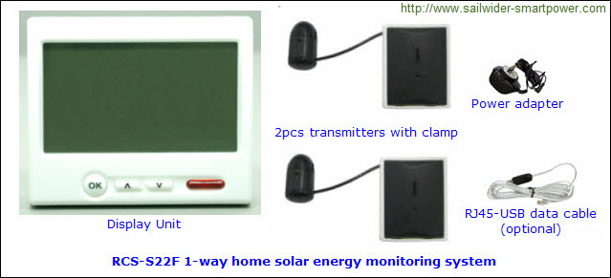
The RCS-S22F wireless home solar energy monitoring system consists of below parts:
- 1pc Display Unit with power adapter:
The Display Unit receives data from the transmitters (one for home, the other for solar) and displays their real time data as well as their balance value on the LCD.
The user can view the energy data of home consumption and solar production as well as the data of each extra transmitter on the Display Unit.
The Display Unit supports batteries for temporary usage if there is no power supply from the power adapter.
- 2pcs 1-way transmitters with sensor clamp: One transmitter is for monitoring the total home energy consumption, the other for monitoring the solar energy production. Both transmitters send the collected data to the Display Unit wirelessly. Each transmitter supports up to 3pcs sensor clamps to support 3-phase.
- 1pc RJ45-USB data cable to provide computer link

- System Installation
Step 1: Power on and Data Resetting.
Locate a place where has a power outlet socket nearby and where is convenient for viewing and operating the Display Unit for home users, then plug the power adapter of the Display Unit into the power outlet.

Now attach the plug of the power adapter into the Display Unit and the LCD will power on and will display the full symbols as below photo:
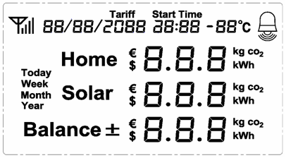
Then the LCD will show the programming version number and then return to the Default Display (but with dash values) as below photo. The dash value means it is not paired or the signal is missing.
The date and time displayed on the LCD are default setting from production, need to be set accordingly.
Default Display: 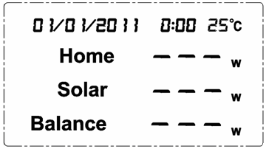
Now keep the Display Unit powered on with the power adapter.
Default Display means what the user usually see from the LCD screen in normal working mode. The top line shows the date, time and temperature. The second line shows the real time home energy consumption in watt. The third line shows the home solar real time energy production. The last line shows the real time balance between home consumption and solar production.

Step 2: Pairing of the Display Unit with the 1-way Transmitters
The 2pcs 1-way transmitters are used to monitor respectively the total home electricity consumption and the total electricity output of the home solar plant. Please pair them with the Display Unit according to below instruction. The transmitters themselves have no difference (if the fixed clamps are with the same diameter), so the user can choose any transmitter to pair for the solar plant or for the total home consumption. But after pairing, the transmitter’s role (for home consumption or for solar production) in the system is fixed.

Before pairing, please remove the clear plastic tab located on the back of the transmitter (marked: REMOVE BEFORE USING). The tab is an insulation sheet and once it is removed, the batteries inside will power on the transmitter and enable it to start sending signal to the Display Unit.

To pair the Display Unit with the transmitter for the solar energy production:
The channel number for the solar energy production is CH01. Upon the Default Display, press the "UP" key of the Display Unit shortly to switch to CH01 as below photo.
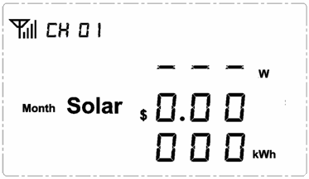
Then press the “DOWN” key and hold it there for 3 seconds until LED indicator of the Display Unit quickly gives a flash and the LCD enters into below display where the antenna icon flashes at the corner, then release the “DOWN” key. Now channel number CH01 (solar channel) of the Display Unit is in pairing mode.
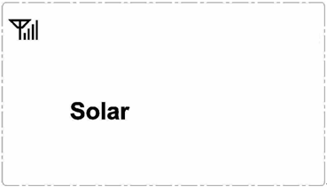
Keep the transmitter close to the Display Unit in the same room. Make sure that the plastic tab has been removed.
Now use a slim stick to push into the pairing hole of the transmitter (as shown in below photo) and hold it there for 3 seconds until the LED light of the transmitter flashes quickly. Then release the slim stick and the transmitter is starting to pair with the Display Unit.
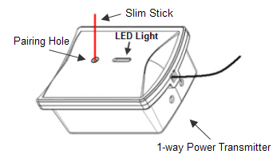
After the Display Unit pairs successfully with the transmitter, its LCD screen will automatically return to its Default Display, where the dashes of solar value turn to be 0. After successful pairing, we suggest you to stick a label of “Solar Production” or any other similar words on the transmitter to avoid confusion.
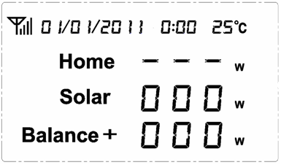
The Display Unit will stay in pairing mode for 60 seconds while the transmitter stays in the pairing mode for 30seconds. If the pairing was not successful within this period, please try the pairing from the start again. Pressing the “OK” key anytime during pairing will exit the pairing.

To pair the Display Unit with the transmitter for the total home electricity energy consumption:
The channel number for home consumption is CH02. Upon the Default Display, press the "UP" key of the Display Unit twice shortly to switch to CH02 as below photo.
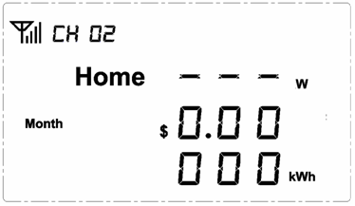
Then press the “DOWN” key and hold it there for 3 seconds until LED indicator of the Display Unit quickly gives a flash and the LCD enters into below display where the antenna icon flashes at the corner, then release the “DOWN” key. Now channel number CH02 (home channel) of the Display Unit is in pairing mode.
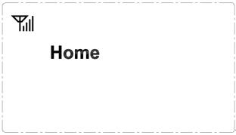
Do the same on the transmitter for home energy consumption to finish the pairing. After successful pairing, we suggest you to stick a label of “Home Total Consumption” or any other similar words on the transmitter to avoid confusion.

To pair the Display Unit with extra transmitters:
The user may have bought extra transmitters for some specific monitoring targets. Please just use channel number CH03-CH15 of the Display Unit to pair with them. The pairing process is the same. After successful pairing, the user can switch to their channels on the LCD to view their data.

Step 3: Installation of the 1-way Power Transmitter and the Sensor Clamp
To install the transmitter and sensor clamp for the total home electricity energy consumption:
Place the transmitter labeled with “home total consumption” near the input trunk cables for home (usually under the electricity meter). Fix the Sensor Clamp around the live wire or the null wire of the input trunk cables for the home. Make sure to let the wire pass through the clamp. (for 3-phase, please refer to the description in the next page)
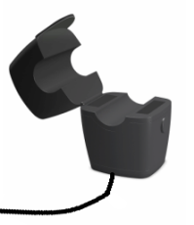
The Sensor Clamp immediately starts to detect the current and the transmitter sends the data to the Display Unit. The monitoring system now starts to monitor the electricity energy consumption of home. And the user will begin to see the real data of home energy consumption on the LCD of the Display Unit.

The transmitter can be put flat in a dry place nearby or be stuck on the wall nearby.

To install the transmitter and sensor clamp for the solar energy output:
Place the transmitter labeled with “Solar Production” near the output trunk cable of the solar energy plant. Fix the Sensor Clamp around the live wire or the null wire of the output trunk cable for the home solar plant. Make sure to let the wire pass through the clamp. The Sensor Clamp immediately starts to detect the current and the monitoring system starts to monitor the electricity output of the home solar plant.

Regarding the location of where to use the sensor clamps, please refer to below diagram.
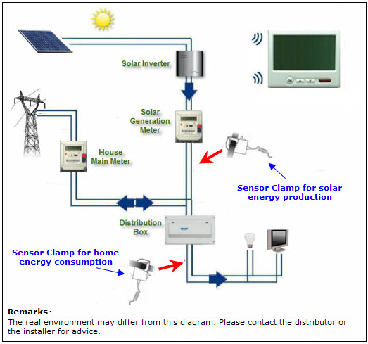
Note: There are three kinds of optional sensor clamps for different diameter wire: 10mm, 18mm and 25mm (as shown in below photo).
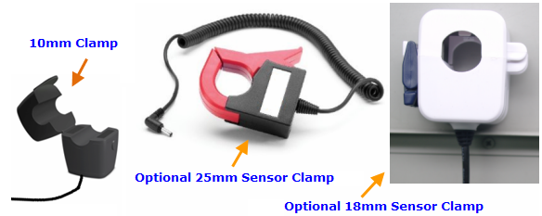

3-phase power supply
If the monitoring target is 3-phase, the user needs two more sensor clamps for the transmitter. Attach the DC plug of each extra sensor clamp into the DC sockets on the back of the Transmitter, as per below photo.
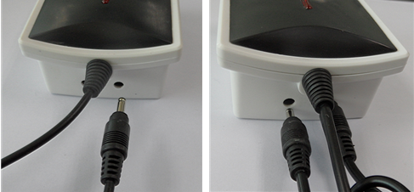

Fix the 3pcs of Sensor Clamps around the lines of Phase-A, Phase-B and Phase-C (Don’t fix the clamps around the ground wire and neutral wire).
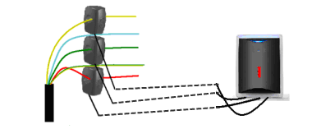
After Installation of the 2pcs 1-way Transmitters and the Sensor Clamps, the user can now see the real data of home energy consumption, solar energy production and their balance value on the LCD screen of the Display Unit, something like below Default Display (example only):
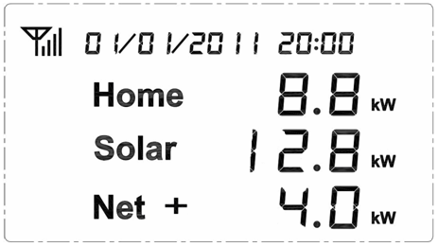
- Resetting, Data Clearance and Programming Version
Warning: The following operation will clear all data from the Display Unit’s memory, including the previous pairing, history data and setting. After resetting, all Transmitters need to do the pairing again with the Display Unit.

- Please pull out the power adapter (and remove the batteries, if they are there) from the Display Unit.
- Then press at the same time the UP and DOWN key and hold it there, then attach the plug of the power adapter into the Display Unit. The LCD screen will display the full LCD symbols as per below photo and after 3 seconds the LED indicator will flash twice.
- Now release the UP and DOWN key, the LED indicator will light up and the LCD screen will display the programming version number for about 3 seconds, as per below photo:
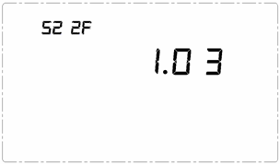
- Then the LCD screen enters into the display screen with zero values, as below photo. The resetting has now been finished and all old data has been cleared.
Note: In case the Display Unit is powered off due to power cut, the data will not be lost.
- Settings of the Display Unit

Settings of Date, Time, Currency, Tariff, CO2 factor, Voltage and Buzzer
Upon the Default Display, press the OK key and hold it there for about 3 seconds until the LCD enters the SETTING Menu, where the date is flashing on the LCD, as per below photo.
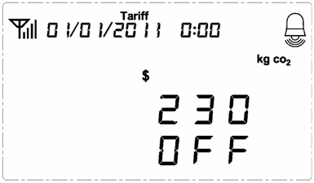
Pressing shortly the UP or DOWN key will make other symbols flashing on the LCD. The scrolling order is date, time, currency, tariff, CO2 factor, voltage and buzzer. When the item is selected it will flash. Pressing the OK key upon the flashing symbol will enter the setting interface for the flashing item. Pressing the DOWN key upon the flashing OFF will exit the setting and return the LCD back to the Default Display. Let’s now start the setting from Date.

1) Date setting
When (day/month/year) is flashing on the SETTING MENU, press the OK key shortly and enter into the setting interface for date. Use the UP key or the DOWN key to set the correct value for each flashing number and press OK key to confirm the value.

2) Time setting
The confirmation of the day value of the date will exit the setting for date and return the LCD back to the SETTING MENU, where the time will begin to flash on the LCD. Press the OK key to set the time.
Operate the same way to use the UP key or the DOWN key to set the correct value for each flashing number and press OK key to confirm the value.

3) Currency setting
The confirmation of the minute value of the time will exit the setting for time and return to the SETTING MENU, where the currency symbol will begin to flash on the LCD. Press the OK key to set currency.
Operate the same way to use the OK key and the UP/DOWN key to set the correct currency accordingly. This system supports 2 kinds of currency: and .

4) Tariff setting
The confirmation of the currency symbol will exit the setting for currency and the symbol will begin to flash on the LCD.

This system supports up to three tariffs for the home electricity consumption and single tariff for the solar production. Any data related to money is calculated according to the setting of the tariffs.
Press the OK key upon the flashing to enter the setting interface of home electricity consumption tariff.

First it is the number 01 flash under the symbol . Press the UP or DOWN key will switch it among 01, 02 and 03. If there is only one tariff per day (single tariff), press OK key upon the flashing “01”. If there are two tariffs per day (2-tariff), press OK key upon the flashing “02”. If there are three tariffs per day (3-tariff), press OK key upon the flashing “03”.
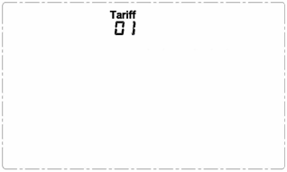
For single tariff setting: After pressing the OK key upon the flashing “01” under the symbol , the LCD enters the interface for single tariff setting. Please use the DOWN/UP key to get the correct value for each flashing value accordingly then shortly press the OK key to confirm. The confirmation of the last flashing digit will lead the LCD to the setting interface for solar energy tariff. Operate the same way to set the tariff for solar.
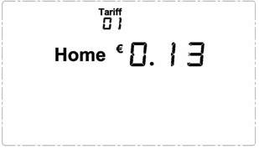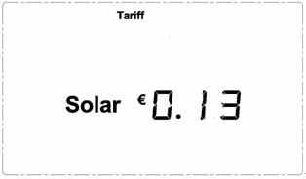
The confirmation of the last flashing digit will exit the setting for tariff and return the LCD back to the SETTING MENU, where the symbol will begin to flash on the LCD.

For 2-tariff setting: After pressing the OK key upon the flashing “02” under the symbol , the LCD enters the interface for 2-tariff setting as below photo:
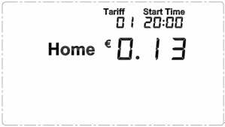
This is the first tariff to be set. Please use the the DOWN/UP key to get the correct value for each flashing value accordingly then shortly press the OK key to confirm. After the confirmation of the first tariff, the time will begin to flash on the LCD. This is the start time for tariff 1. Please use the the DOWN/UP key to get the correct value for each flashing value accordingly then shortly press the OK key to confirm. After that, the LCD will turn to setting interface for the second tariff. Set the tariff value and start time the same way accordingly.
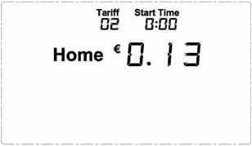
The confirmation of the starting time of the second tariff will lead the LCD to the setting interface for solar energy tariff. Operate the same way to set the tariff for solar. Solar supports only single tariff, so there is no need to set the start time.
The confirmation of the solar tariff will exit the setting for tariff and the symbol will begin to flash on the LCD.

For 3-tariff setting: After pressing the OK key upon the flashing “03” under the symbol , the LCD enters the interface for 3-tariff setting as below photo:
This is the first tariff to be set. Please use the the DOWN/UP key to get the correct value for each flashing value accordingly then shortly press the OK key to confirm. After the confirmation of the first tariff, the time will begin to flash on the LCD. This is the start time for tariff 1. Please use the the DOWN/UP key to get the correct value for each flashing value accordingly then shortly press the OK key to confirm. After that, the LCD will turn to setting interface for the second tariff.
Set the tariff value and start time the same way accordingly for the second tariff. And the confirmation of the starting time of the second tariff will lead the LCD to the setting interface for the third tariff. Operate the same way to set the tariff value and the start time for the third tariff.
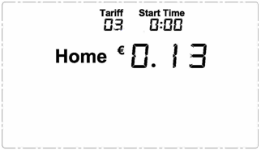
The confirmation of the start time of the third tariff will lead the LCD to the setting interface for solar energy tariff. Operate the same way to set the tariff for solar. Solar supports only single tariff, so there is no need to set the start time.
5) CO2 factor setting
The confirmation of the solar tariff will exit the setting for tariff and return the LCD back to the SETTING MENU, where the symbol will begin to flash on the LCD. The CO2 factor is to be used to calculate how much CO2 is produced by the consumption of 1kwh. The default factory is 0.54. If you don’t know much of this, you can use this factor for your reference. Use the UP key or the DOWN key to scroll to the correct value for each flashing number and press OK key to confirm the value.
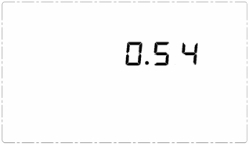
6) Voltage setting
The confirmation of the CO2 factor will return the LCD back to the SETTING MENU, where the number 230 will begin to flash on the LCD. Press the OK key shortly to set the voltage, the same way by pressing the UP/DOWN key and the OK key.
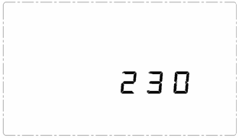
7) Buzzer setting
The confirmation of the voltage will return the LCD back to the SETTING MENU, where the OFF symbol will begin to flash on the LCD. Press the OK key shortly and use the UP/DOWN key to switch between ON/OFF and press the OK key to confirm. This confirmation will exit the whole setting and return the LCD back to the Default Display.
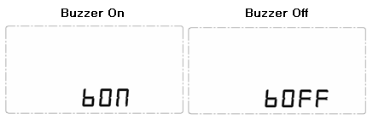
If there is no key operation for 30 seconds during the setting, the LCD will exit the setting automatically.
- “UP TO NOW” History Data Viewing for both Home and Solar
There are four kinds of UP TO NOW history data that can be viewed on the display screen.
: Means the accumulated data for current day up to now from 00:00 of current day.
: Means the accumulated data for current week up to now from 00:00 of Monday of current week.
: Means the accumulated data for current month up to now from 00:00 of the 1st day of current month.
: Means the accumulated data for current year up to now from 00:00 of January 1st of current year.
To view the UP TO NOW history data, please shortly press the OK key to enter into the UP TO NOW history data interface as below photo. The first display is for electricity energy data (kWh) for the current day. The first line displays the home electricity energy consumed up to now for today. The second line displays the solar energy produced up to now for today. The last line is the balance data.
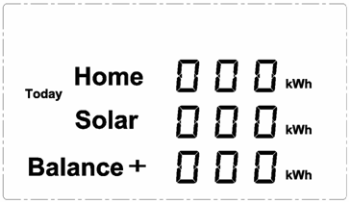
From here, please use the OK key to switch among UP TO NOW data for different time frames of (This Week), (This Month), (This Year) and (Today), as per below photo.
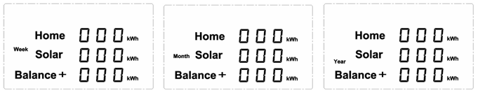
Upon any UP TO NOW data display, pressing the DOWN or UP key can switch among the UP TO NOW data for different data types of COST (), CO2 Emission () and Electricity Amount () for the same time frame, as below photos.
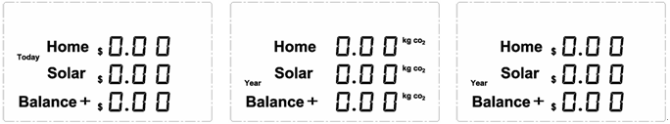
During the viewing, idleness of key operation for 60 seconds will return the LCD screen to the Default Display.
- Data Viewing of Single Channel 01-15
To view the data of each channel, including the home channel, solar channel and extra channels if extra transmitters are paired into the system, please shortly press the DOWN and UP key upon the Default Display and scroll to the desired channel, for example Channel 3 as below photo:
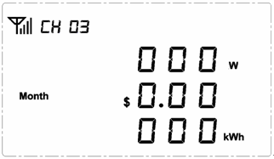
From this display, the first line shows the antenna icon (means paired) and the channel number. The second line shows the real time power consumption of this channel, the third line shows the accumulated energy in money for current month (up to now), the last line shows the accumulated energy in kwh for current month (up to now).

Upon above display, pressing the OK button will switch the time frames. The CO2 emission up to now data will also come in to replace the real time power.

During the viewing, idleness of key operation for 60 seconds will return the LCD screen to the Default Display.

- RJ45-USB Data Cable and Software

The RJ45-USB Data Cable and the software allow you to view your electricity consumption data/Solar production data.

The PC software supports history data viewing of past 40 days and 24 months of Home Energy Consumption and Solar Energy Production.
